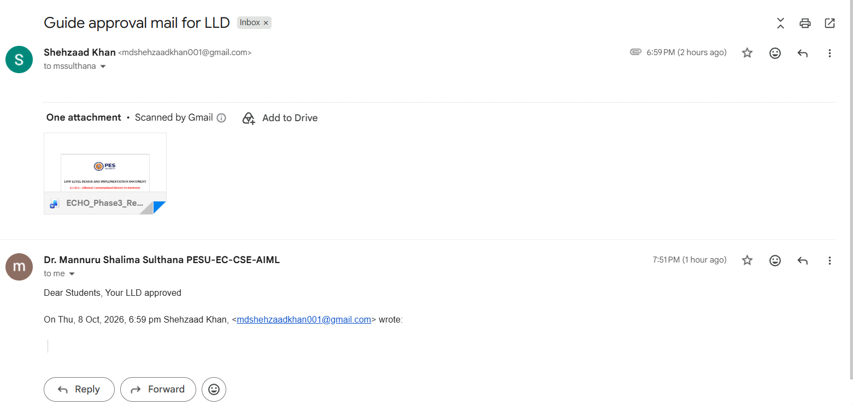



LOW LEVEL DESIGN AND IMPLEMENTATION DOCUMENT

E.C.H.O. – Efficient Contextualized History Orchestrator

UE23CS441A – Capstone Project Phase – 3

Submitted by:

Mrigank Jain  Mohammed Mir Fazlai Ali  Mohammed Shehzaad Khan  Arjun Sai N | PES2UG23CS352  PES2UG23CS346  PES2UG23CS349  PES2UG23CS091

Under the guidance of

Dr. M. Shalima Sulthana
Associate Professor
PES University

August - December 2026

DEPARTMENT OF COMPUTER SCIENCE AND ENGINEERING
FACULTY OF ENGINEERING
PES UNIVERSITY

(Established under Karnataka Act No. 16 of 2013)

Electronic City, Bengaluru – 560 100, Karnataka, India

TABLE OF CONTENTS

- Introduction | 4
1.1 Overview | 4
1.2 Purpose | 4
1.3 Scope | 4
- Design Constraints, Assumptions, and Dependencies | 5
- Design Description | 6
3.1 Master Class Diagram | 7
3.2 Module 1: Memory Capture and Enrichment | 8
3.2.1 Description | 8
3.2.2 Use Case Diagram | 9
3.2.3 Class Diagram | 12
3.2.3.1 Class Name 1: ChromeConnector | 13
3.2.3.6 Class Name 2: YouTubeConnector | 14
3.2.3.11 Class Name 3: GmailConnector | 16
3.2.3.16 Class Name 4: StorageEngine | 18
3.2.3.21 Class Name 5: FAISSManager | 19
3.2.3.26 Class Name 6: EnrichmentPipeline | 21
3.2.3.31 Class Name 7: SystemGroupClassifier | 22
3.2.4 Sequence Diagram | 23
3.3 Module 2: Retrieval and Synthesis Engine (RSE) | 24
3.3.1 Description | 24
3.3.2 Use Case Diagram | 25
3.3.3 Class Diagram | 27
3.3.3.1 Class Name 1: EchoState | 28
3.3.3.4 Class Name 2: ParsedIntent | 29
3.3.3.7 Class Name 3: RetrievalEngine | 29
3.3.3.12 Class Name 4: HybridSearch | 31
3.3.3.18 Class Name 5: QualityGate | 32
3.3.3.23 Class Name 6: Reranker | 33
3.3.3.28 Class Name 7: LLMCalls | 35
3.3.4 Sequence Diagram | 36
3.4 Module 3: Digital Wellbeing and Analytics (WBA) | 36
3.4.1 Description | 36
3.4.2 Use Case Diagram | 37
3.4.3 Class Diagram | 39
3.4.3.1 Class Name 1: WellbeingAnalytics | 39
3.4.3.6 Class Name 2: GroupManager | 40
3.4.3.12 Class Name 3: RegretSystem | 42
3.4.3.17 Class Name 4: InsightGenerator | 43
3.4.4 Sequence Diagram | 44
3.5 Packaging and Deployment Diagram | 44
- Proposed Methodology / Approach | 45
4.1 Algorithm and Pseudocode | 46
4.2 Implementation and Results | 47
4.3 Further Exploration Plans and Timelines | 48
Appendix A: Definitions, Acronyms and Abbreviations | 49
Appendix B: References | 50
Appendix C: Record of Change History | 50
Appendix D: Traceability Matrix | 51

Note:

Section 1 | Common for Prototype/Product Based and Research Projects
Section 2 & 3 | Applicable for Prototype / Product Based Projects.
Section 4 | Applicable for Research Projects.
Appendix | Provide details appropriately

Introduction
  - Overview
E.C.H.O. addresses fragmented personal digital history across Gmail, Chrome, and YouTube. Instead of forcing users to remember which application contained a previous interaction, the system creates a unified, searchable memory layer.
The system captures meaningful activity, stores source-aware canonical records, enriches them for semantic search, retrieves context through hybrid deterministic retrieval, and presents results through a React dashboard and Chrome extension popup.
Phase III focus: system integration, reliable enrichment/indexing, retrieval-quality improvements, digital wellbeing analytics, and UI completion.
This low-level design describes how each part of E.C.H.O. is built: its modules, classes, data members, methods, algorithms, and how they are packaged and deployed.
  - Purpose
The purpose of this document is to record the low-level design and the implementation status of E.C.H.O. at Capstone Phase 3 Review 2. It explains, module by module, which classes exist, what data they hold, what each important method does, and the algorithms behind retrieval and wellbeing. It is the reference for the remaining implementation work and for tracing the design back to the requirements (Project Scope Document) and the high-level design (Architecture Design Document).
  - Scope
The E.C.H.O. system encompasses:
- Gmail, Chrome, and YouTube activity capture
- Canonical memory storage with source-specific metadata
- Intent-aware capture and revisit detection
- Background enrichment, classification, and FAISS semantic indexing
- Natural-language hybrid retrieval with conversational context
- Digital wellbeing analytics and user-controlled reflections
- React dashboard, browser extension popup, settings, export
All functionality is designed with privacy-first principles and local-first architecture.
This document covers the system up to the Digital Wellbeing module, in three functional modules: Memory Capture and Enrichment (Section 3.2), the Retrieval and Synthesis Engine (Section 3.3), and Digital Wellbeing and Analytics (Section 3.4). The user-interface layer appears in the packaging and deployment view (Section 3.5) and in the plan for the remaining work (Section 4.3).

Design Constraints, Assumptions, and Dependencies
The design follows the constraints, assumptions, and dependencies below. The constraints are deliberate design decisions; each is enforced in code, not only in documentation.
Design constraints
- Local-first: no permanent cloud copy of personal data.
- No capture of typed text, incognito tabs, or application pages (Slack, Notion) — application pages are recorded for time spent only.
- Exactly 2 LLM calls per query: one to parse the question, one to write the answer.
- The LLM sees only the question, prior turns, short snippets, and aggregated numbers — plus an attachment's extracted text when the user asks about that attachment.
- The 16-table database schema is locked.
- Wellbeing language stays descriptive — no scores, no "wasted time".
- No item joins a user group without the user's approval.
Assumptions
- A single user on desktop Chrome.
- Gmail, Chrome, and YouTube cover most relevant activity.
- Engagement (time, scroll, revisits) approximates effort.
- Google APIs stay available and stable.
Dependencies
Dependency | Used for | Impact if it fails
Gmail API, YouTube Data API v3 | Email capture; video title, channel, and duration | Capture stops if an API or its OAuth token fails
Chrome Manifest V3 extension APIs | Chrome page and YouTube watch capture | Chrome and YouTube capture rely on them
PostgreSQL, Redis, FAISS | Storage layers | PostgreSQL is the source of truth; FAISS can be rebuilt from PostgreSQL
Local models (MiniLM, cross-encoder) | Embeddings and re-ranking | One-time download on first run
OpenAI gpt-4.1-mini (swappable) | Intent parsing and answer writing | Paid API with a small cost per query; switching provider is one configuration change

Design Description
Design approach. E.C.H.O. is a layered, modular monolith — private, intent-aware memory with deterministic retrieval-augmented generation: fixed Python search steps, with the LLM only writing the final answer. This keeps data on the device, cuts noise, unifies search across sources, makes results explainable, and let four people build modules in parallel.
The design is described in three functional modules:
Module | Packages | Responsibility
Module 1 — Memory Capture and Enrichment | extension/, ingestion/, ste/, enp/ | Capture engaged activity, store it atomically, enrich and index it in the background
Module 2 — Retrieval and Synthesis Engine (RSE) | rse/, backend/retrieval.py | Answer natural-language questions with hybrid search and exactly 2 LLM calls
Module 3 — Digital Wellbeing and Analytics (WBA) | wba/, backend/wellbeing.py | Describe time use, sessions, regret, and user groups — with the user in control

Implementation note. E.C.H.O. is written in Python. Where a component is a module of functions rather than a Python class (for example ingestion/chrome/chrome_connector.py), it is documented as a class: its module-level constants and request fields are its data members, and its functions are its methods. Access modifiers follow the Python convention — a leading underscore marks a private member; everything else is public.
  - Master Class Diagram
The master class diagram gives the whole system at a high level. It is broken down into one class diagram per module in Sections 3.2.3, 3.3.3, and 3.4.3, which show the classes as implemented.
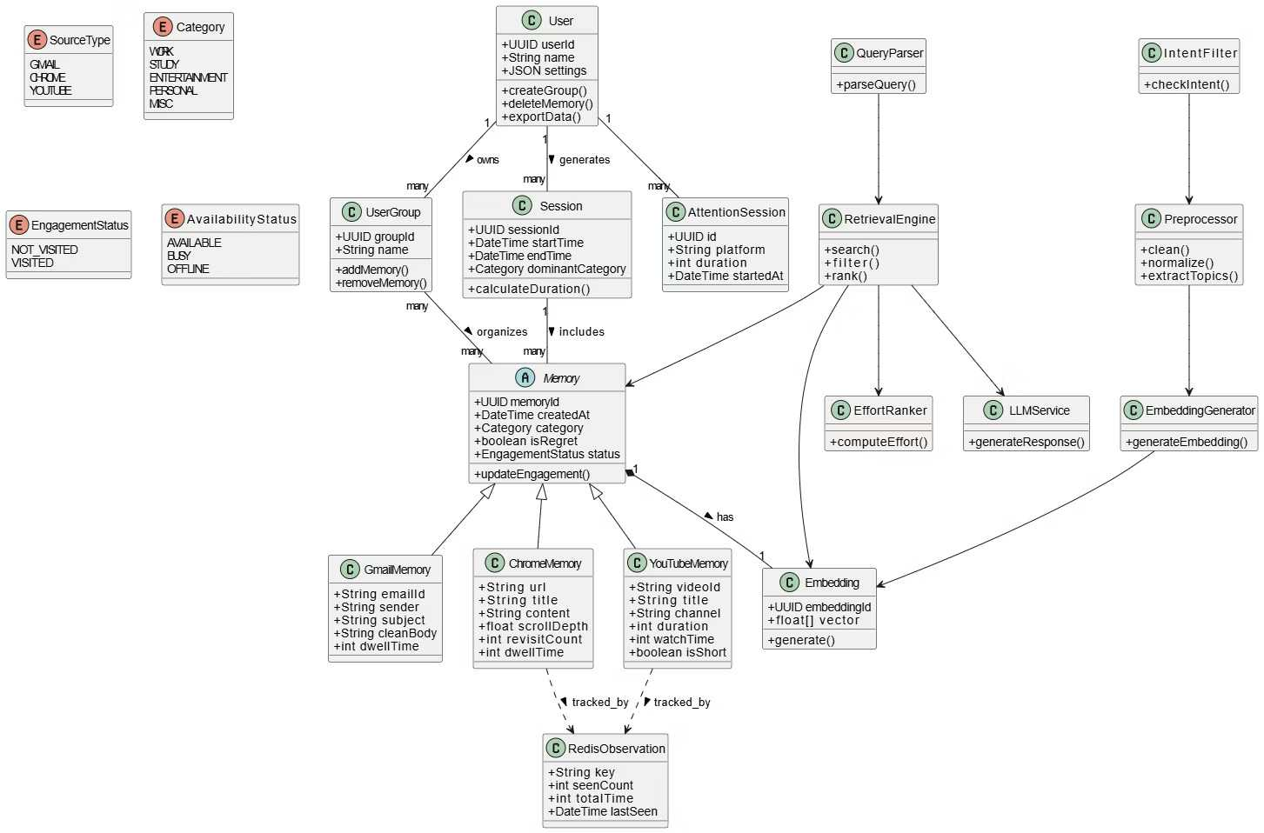
Figure 1: Master class diagram (Phase II design, high level)
How the high-level classes map to the implementation:
Master diagram class | Implemented as
Memory, GmailMemory, ChromeMemory, YouTubeMemory | memory_items plus one source table each (gmail_metadata, chrome_metadata, youtube_metadata), written by StorageEngine
AttentionSession | memory_engagement — dwell time, watch time, play sessions
IntentFilter | ingestion/chrome/intent_filter.py and YouTubeConnector.passes_intent_gate()
Preprocessor | enp/text_cleaner.py and enp/topic_extractor.py
EmbeddingGenerator, Embedding | enp/embedding_generator.py; vectors held by FAISSManager and the embedding_index table
QueryParser, LLMService | rse/query_parser.py and rse/llm_synthesizer.py — the 2 LLM calls
RetrievalEngine | rse/retrieval_engine.py — a 14-node LangGraph
EffortRanker | rse/reranker.py — cross-encoder plus effort score
Session, UserGroup | wba/wellbeing_analytics.py and wba/group_manager.py
RedisObservation | Redis revisit keys in ste/redis_manager.py (24-hour expiry)
User | Single-user installation — there is no users table

  - Module 1: Memory Capture and Enrichment
    - Description
Module 1 turns everyday activity into stored, searchable memory. It has three parts that run inside the same backend process:
- Capture (extension/, ingestion/). The Chrome extension watches web pages and YouTube videos in desktop Chrome and sends an event only after its intent gate passes; the backend repeats the same gate before saving. Gmail is polled every 30 seconds through the Gmail API with a read-only scope. Every new email — received or sent — is stored, and reading time is added when the extension sees the user open it.
- Storage (ste/). The Storage Engine is the single write path. Each item is written to memory_items, its source table, and memory_engagement in one transaction, de-duplicated by UNIQUE(source_type, source_id). Redis holds short-lived keys — revisits (24 hours), attachment text, a copy of each newly stored email, and the encrypted Gmail token (1 hour each) — and the capture settings.
- Enrichment (enp/). A background thread picks up items that are not yet processed, cleans their text, builds a 384-dimension MiniLM embedding, assigns one of five system groups (work, study, entertainment, personal, misc), and appends the vector to the FAISS index. Capture never waits for enrichment.
Privacy rules are enforced at capture time: incognito tabs and typed text are never captured; login, payment, and account pages are discarded; application pages such as Slack and Notion are stored for time spent only, with no content.
    - Use Case Diagram
The use cases are shown at two levels. Level 0 covers the whole system; each module then has its own level-1 diagram (this section, 3.3.2, and 3.4.2). Dashed arrows are «include» relations.
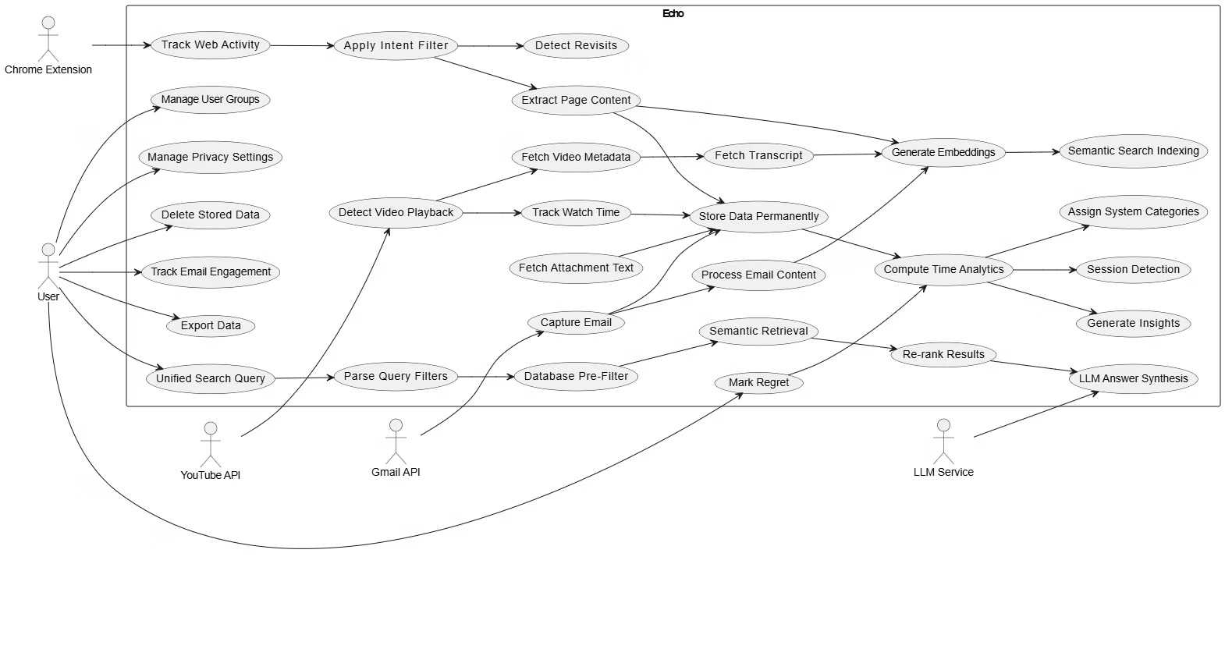
Figure 2: Level 0 — system use case diagram (Phase II design)
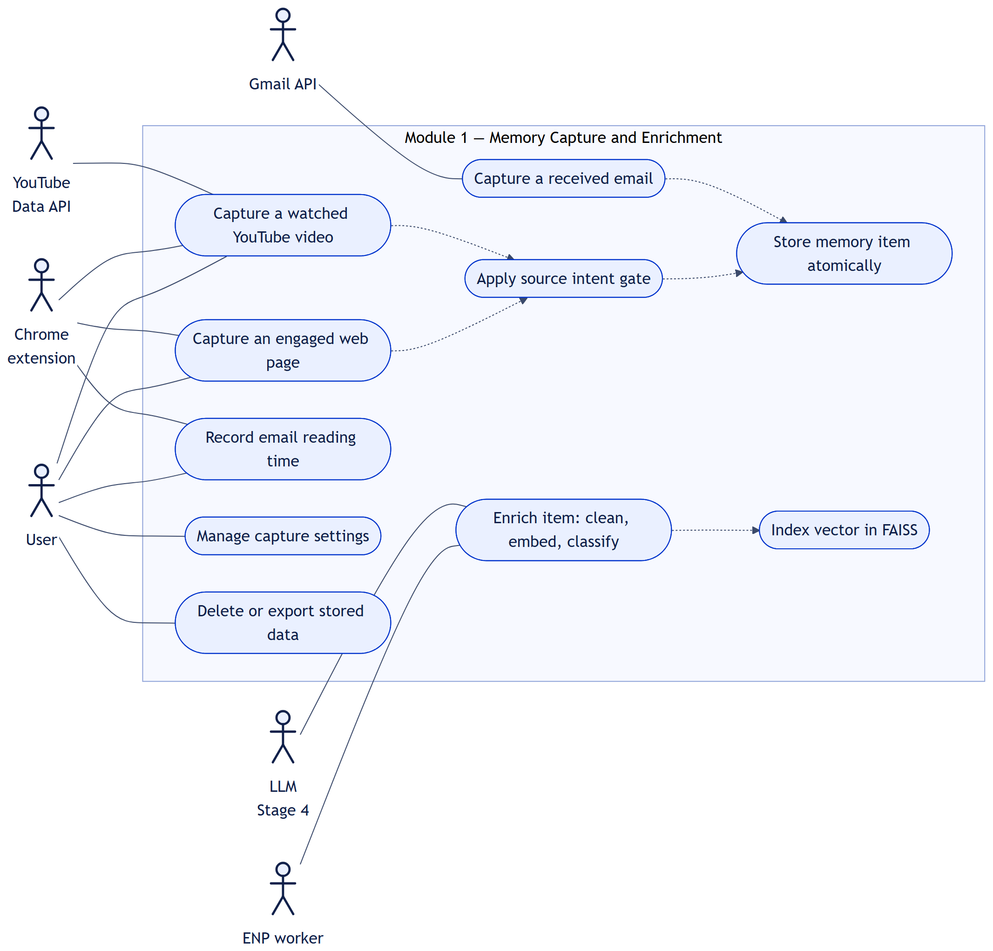
Figure 3: Level 1 — Memory Capture and Enrichment
Use Case Item | Description
Capture an engaged web page | The extension sends a page after 5 s of exposure, then any one of: 10 s in the foreground, 25% scroll, one interaction, or a revisit; the backend repeats the gate and stores it.
Capture a watched YouTube video | Stored after 20 s of playback (15 s for Shorts), 50% completion, a revisit within 24 hours, or a manual interaction; title, channel, and duration are fetched afterwards.
Capture a received email | A background poll every 30 s stores each new email — read or unread, received or sent — with sender, labels, thread, and attachment details.
Record email reading time | When the user opens an email in Gmail, the extension reports the dwell time, which is added to that email's engagement.
Apply source intent gate | Keeps only content the user paid attention to; the same thresholds run in the extension and the backend.
Store memory item atomically | One transaction per item; a repeated item is recognised and not stored twice.
Enrich item | Clean, embed, classify, and index in the background; failures are recorded and can be retried.
Manage capture settings | Turn each source on or off, and exclude domains or senders.
Delete or export stored data | Soft delete (DELETE /items/{id}) and export as JSON or CSV (GET /export).

    - Class Diagram
The classes of Module 1 and how they depend on each other. Supporting modules not detailed below — settings_store.py, redis_manager.py, postgresql_manager.py, text_cleaner.py, topic_extractor.py, and embedding_generator.py — are small helpers called by these classes.
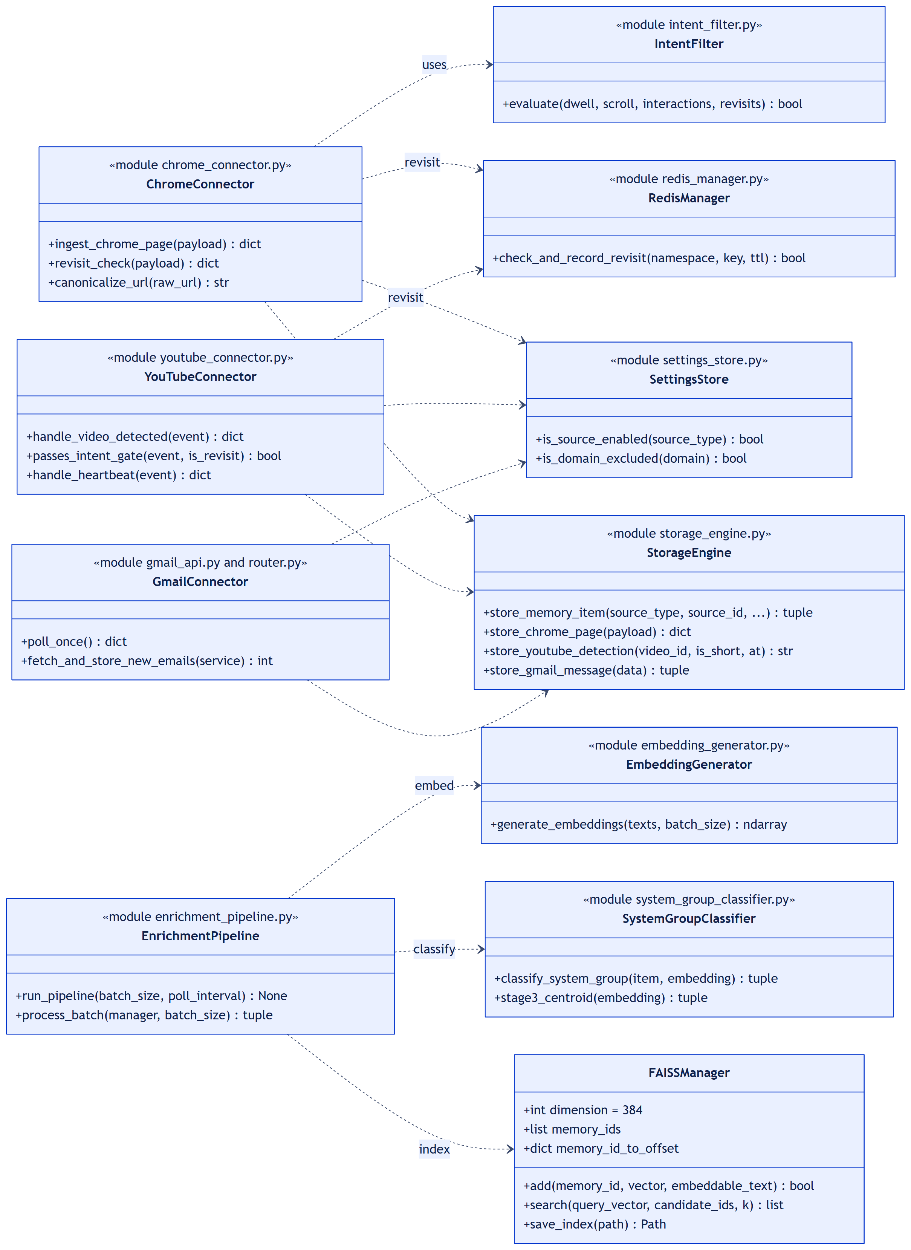
Figure 4: Class diagram — Memory Capture and Enrichment
      - Class Name 1: ChromeConnector
      - Class Description 1
File: ingestion/chrome/chrome_connector.py with intent_filter.py. A FastAPI router mounted at /chrome. It receives page events that the Chrome extension sends once its own intent gate passes, re-checks them on the server, and stores admitted pages through the Storage Engine. Its request body is the Pydantic model ChromeIngestRequest.
      - Data Members 1
Data Type | Data Name | Access Modifiers | Initial Value | Description
str | url | public | — | Page URL as visited
str | canonical_url | public | None | URL without tracking parameters and fragment
str | title | public | — | Page title
str | domain | public | — | Lower-case host name
int | dwell_seconds | public | — (≥ 0) | Foreground seconds when the intent gate passed (sent once per visit)
float | scroll_depth | public | — (0 to 1) | Deepest scroll position
int | interaction_count | public | — (≥ 0) | Clicks and text selections
int | revisit_count | public | 0 | Earlier visits in the last 24 hours
str | content_extract | public | None | Main page text extracted by the extension
bool | is_app_page | public | False | True for application pages — time only, no content
set | IGNORED_QUERY_PARAMS | public, constant | 11 keys | Tracking parameters removed (utm_*, fbclid, gclid, …)
tuple | SENSITIVE_PATH_TERMS | public, constant | 14 terms | Pages with login, payment, account, … in the path are never stored
int | PHASE1_MIN_SECONDS | public, constant | 5 | Intent gate phase 1: minimum exposure
int / float | PHASE2_MIN_FOREGROUND, PHASE2_MIN_SCROLL, PHASE2_MIN_INTERACTIONS | public, constant | 10 s, 0.25, 1 | Intent gate phase 2: any one is enough

      - Method 1: ingest_chrome_page()
- Purpose: Admit or discard one page event and store admitted pages (POST /chrome/ingest).
- Input: JSON body from the extension, validated as ChromeIngestRequest.
- Output: {status: "saved", memory_id, mode} or {status: "discarded", reason}.
- Parameters: payload: ChromeIngestRequest
- Exceptions: Invalid fields are rejected with HTTP 422 by validation. A database error from the Storage Engine returns HTTP 500. A Redis error while recording the visit is logged and ignored.
- Pseudo-code:
canonical_url = payload.canonical_url or canonicalize_url(payload.url)
if chrome capture is off or domain is excluded: return discarded
if application path or sensitive page: return discarded
if dwell_seconds >= 5: record visit in Redis (expires in 24 h)
if is_app_page: drop the content (time only)
elif not intent_filter.evaluate(dwell, scroll, interactions, revisits):
return discarded
saved = StorageEngine.store_chrome_page(payload)
return saved(memory_id, mode)
      - Method 2: intent_filter.evaluate()
- Purpose: Two-phase intent gate. The thresholds match the extension exactly, so a page the extension sends is never silently dropped by a stricter server.
- Input: Engagement signals of one page.
- Output: True to keep the page, False to discard it.
- Parameters: dwell_seconds: int, scroll_depth: float, interaction_count: int, revisit_count: int
- Exceptions: None — a pure function.
- Pseudo-code:
if dwell_seconds < 5: return False # phase 1
return dwell_seconds >= 10 or scroll_depth >= 0.25
or interaction_count >= 1 or revisit_count > 0 # phase 2
      - Class Name 2: YouTubeConnector
      - Class Description 2
File: ingestion/youtube/youtube_connector.py. A FastAPI router mounted at /ytc with three routes: /video-detected, /heartbeat, and /video-closed. A video is stored as soon as it passes the intent gate; its title, channel, and duration are fetched afterwards from the YouTube Data API without blocking the response. Watch time is updated by the heartbeat and closing events.
      - Data Members 2
Data Type | Data Name | Access Modifiers | Initial Value | Description
str | url | public | — | Watch or Shorts URL
str | video_id | public | — | 11-character YouTube id, validated
bool | is_short | public | — | Reported by the extension; re-derived from the URL
int | watch_time_seconds | public | — | Foreground playback time so far
str | triggered_by | public | — | What fired the event, e.g. manual_interaction
int | duration_seconds | public | None | Video length, when the page reports it
datetime | timestamp | public | — | Time the video was detected
int | SHORT_MIN_WATCH_SECONDS | public, constant | 15 | Watch-time bar for Shorts
int | REGULAR_MIN_WATCH_SECONDS | public, constant | 20 | Watch-time bar for regular videos
float | COMPLETION_RATE_THRESHOLD | public, constant | 0.5 | Alternative bar: half the video
ThreadPoolExecutor | executor | public | 4 workers | Runs blocking database writes off the event loop

      - Method 1: handle_video_detected()
- Purpose: Gate and store a newly watched video, then fill in its metadata in the background (POST /ytc/video-detected).
- Input: JSON body validated as VideoDetectedEvent.
- Output: {status: "saved", memory_id, video_id, is_short, triggered_by} or {status: "discarded", reason}.
- Parameters: event: VideoDetectedEvent
- Exceptions: A failed database write returns HTTP 500 ("Failed to save video memory"). A Redis error counts as "not a revisit". A metadata-fetch error is logged by the background task.
- Pseudo-code:
if youtube capture is off: return discarded
if video_id is not valid: return discarded
is_revisit = Redis.check_and_record_revisit("youtube", video_id)
if not passes_intent_gate(event, is_revisit): return discarded
is_short = classify_video_type(event.url) == "short"
memory_id = StorageEngine.store_youtube_detection(video_id, is_short,
timestamp)
in background: meta = fetch_video_metadata(video_id)
StorageEngine.update_youtube_metadata(memory_id, meta)
return saved
      - Method 2: passes_intent_gate()
- Purpose: Decide whether the user actually watched the video.
- Input: The detection event and whether the video was seen earlier today.
- Output: True to store the video.
- Parameters: event: VideoDetectedEvent, is_revisit: bool
- Exceptions: None — a pure function.
- Pseudo-code:
min_watch = 15 if event.is_short else 20
if event.watch_time_seconds >= min_watch: return True
if duration known and watch_time / duration >= 0.5: return True
if is_revisit: return True
if manual interaction with an interaction type: return True
return False
      - Class Name 3: GmailConnector
      - Class Description 3
Files: ingestion/gmail/gmail_api.py and router.py. A background task started with the backend polls Gmail every 30 seconds with the read-only scope. There is no intent gate on receipt — every new email, received or sent, is stored — but reading time is recorded only when the user opens the email (POST /gmail/engagement). The OAuth token is stored encrypted (token_gmail.enc). Mail in the Spam folder is not listed, so it is never captured.
      - Data Members 3
Data Type | Data Name | Access Modifiers | Initial Value | Description
list[str] | SCOPES | public, constant | gmail.readonly | OAuth scope — read-only access
int | CHECK_INTERVAL | public, constant | 30 | Seconds between polls
Path | TOKEN_PATH | public, constant | token_gmail.enc | Encrypted OAuth token file
Resource | _service | private | None | Cached Gmail API client, built on first poll
str | email_id | public | — | Engagement event: Gmail message id
int | dwell_seconds | public | — (≥ 0) | Engagement event: time the email was open

      - Method 1: poll_once()
- Purpose: Run one polling cycle. Also called by the retrieval engine for "today / just received" questions, so new mail is included immediately.
- Input: None.
- Output: {status: "ok", processed: n} or {status: "skipped", reason: "gmail_capture_disabled", processed: 0}.
- Parameters: None.
- Exceptions: An authentication error propagates to the polling loop, which logs it and tries again after 30 seconds.
- Pseudo-code:
if gmail capture is off: return skipped
initialize_database()
service = cached authenticate_gmail()
processed = fetch_and_store_new_emails(service)
return ok(processed)
      - Method 2: fetch_and_store_new_emails()
- Purpose: List messages, skip those already stored, and store new ones oldest first.
- Input: An authorised Gmail API client.
- Output: Number of emails stored in this cycle.
- Parameters: service: googleapiclient Resource
- Exceptions: Gmail API calls are retried with exponential back-off (4 attempts). Any other error is logged and the cycle returns 0; the next cycle starts clean.
- Pseudo-code:
ids = page through messages.list(maxResults=100)
for id not yet in gmail_metadata:
msg = messages.get(id, format=full); read Subject, From, To, Date
sort new messages by Date, oldest first
for each message:
if sender is excluded in settings: skip
record = body, attachment details, labels, thread_id, is_sent
if StorageEngine.store_gmail_message(record) inserted: count += 1
return count
      - Class Name 4: StorageEngine
      - Class Description 4
File: ste/storage_engine.py. The single write path for all three connectors. store_memory_item() writes memory_items, the source table, and memory_engagement in one database transaction, so a crash can never leave half an item (Gmail attachment rows follow in a second transaction). Duplicates are prevented by UNIQUE(source_type, source_id) with ON CONFLICT DO NOTHING, which makes every connector safe to restart. New items start with preprocessed = FALSE and a provisional system group (Gmail → personal, Chrome → misc, YouTube → entertainment) that the Enrichment Pipeline later replaces.
      - Data Members 4
Data Type | Data Name | Access Modifiers | Initial Value | Description
dict[str, int] | SYSTEM_GROUP_IDS | public, constant | work 1, study 2, entertainment 3, personal 4, misc 5 | Ids of the five system groups; system_group_id is never NULL
Engine | postgresql_manager._engine | private | None → pool on first use | SQLAlchemy pool: 5 connections, 10 overflow, recycled every 240 s

      - Method 1: store_memory_item()
- Purpose: Store one captured item and its metadata atomically.
- Input: Canonical fields of the item plus source metadata and engagement.
- Output: (memory_id, created_new) — created_new is False when the item already existed.
- Parameters: source_type: str, source_id: str, system_group_id: int, title: str, raw_text: str | None, created_at: datetime, source_metadata: dict, engagement: dict | None
- Exceptions: ValueError for an unsupported source type or an existing row that cannot be found. Any database error rolls back the whole transaction.
- Pseudo-code:
begin transaction
INSERT INTO memory_items (..., preprocessed = FALSE,
classified_by = 'pending')
ON CONFLICT (source_type, source_id) DO NOTHING RETURNING memory_id
if a row was inserted: created_new = True
else: memory_id = existing id; update title / text if new values given
upsert the source table (gmail / chrome / youtube metadata)
upsert memory_engagement: dwell adds up, watch time keeps the maximum
commit; return (memory_id, created_new)
      - Method 2: store_chrome_page()
- Purpose: Map an admitted Chrome page onto store_memory_item().
- Input: The validated ChromeIngestRequest.
- Output: {memory_id, inserted}.
- Parameters: payload: ChromeIngestRequest
- Exceptions: Propagates database errors to the caller (HTTP 500).
- Pseudo-code:
return store_memory_item(
source_type = "chrome", source_id = canonical_url, group = misc,
title = title or canonical_url,
raw_text = None if is_app_page else content_extract,
metadata = url, domain, referrer, scroll, interactions, revisits,
engagement = dwell_time_seconds, play_sessions_count = 1)
      - Class Name 5: FAISSManager
      - Class Description 5
File: ste/faiss_manager.py — a Python class. It holds the semantic index: a FAISS IndexFlatL2 over unnormalised 384-dimension MiniLM vectors, mirrored by a numpy array that is the source of truth. Where a similarity threshold matters (quality gate, KNN groups, centroids), callers compute true cosine similarity from these vectors instead of reading L2 distance. The index is saved as enp/echo_faiss.index with a metadata file, and each vector has a row in embedding_index so the index can be rebuilt from PostgreSQL.
      - Data Members 5
Data Type | Data Name | Access Modifiers | Initial Value | Description
int | dimension | public | 384 | Vector length (all-MiniLM-L6-v2)
str | embedding_version | public | all-MiniLM-L6-v2-v1 | Model version recorded with the index
Path | index_path | public | enp/echo_faiss.index | Index file (overridable by environment)
list[str] | memory_ids | public | [] | Memory id stored at each vector offset
dict[str, int] | memory_id_to_offset | public | {} | Reverse lookup: memory id → offset
IndexFlatL2 | _index | private | empty index | FAISS index derived from the buffer
bool | _index_stale | private | False | True after an in-place update; rebuilt on next read
ndarray | _buffer | private | 0 × 384 | Vector cache; grows by doubling
int | _count | private | 0 | Number of vectors in use

      - Method 1: add()
- Purpose: Add a new item's vector, or replace the vector of an item that is re-embedded.
- Input: Memory id, its vector, and the text that was embedded.
- Output: True for a new item, False when an existing vector was replaced.
- Parameters: memory_id: str, vector: ndarray, embeddable_text: str | None
- Exceptions: ValueError if the vector is not 384-dimensional.
- Pseudo-code:
if memory_id already indexed:
overwrite its row in _buffer; _index_stale = True
upsert embedding_index row; return False
grow _buffer if full (doubling); append vector
memory_ids.append(memory_id); memory_id_to_offset[memory_id] = offset
if not _index_stale: _index.add(vector)
upsert embedding_index row; return True
      - Method 2: search()
- Purpose: Nearest neighbours of a query vector among a given set of candidate items.
- Input: Query vector, candidate memory ids, and k.
- Output: List of (memory_id, L2 distance), nearest first.
- Parameters: query_vector: ndarray, candidate_ids: Iterable[str], k: int = 20
- Exceptions: ValueError for a wrong vector size; unknown ids are skipped.
- Pseudo-code:
ids = candidates that are indexed; if none: return []
temp = IndexFlatL2 built from the candidates' vectors
distances, offsets = temp.search(query, min(k, len(ids)))
return [(ids[offset], distance) ...]
      - Class Name 6: EnrichmentPipeline
      - Class Description 6
File: enp/enrichment_pipeline.py. The background worker. The backend starts it at boot as a thread inside the same process; it can also run on its own. Every 10 seconds it takes up to 10 unprocessed items, prepares them (source context, cleaned text, embeddable text, keywords), embeds them in one batch, classifies them, indexes them, and marks them processed. A failed item is marked failed with the reason and is retried on demand.
      - Data Members 6
Data Type | Data Name | Access Modifiers | Initial Value | Description
int | DEFAULT_BATCH_SIZE | public, constant | 10 | Items per batch
int | DEFAULT_POLL_INTERVAL | public, constant | 10 | Seconds between batches
str | FAILED_CLASSIFIED_BY | public, constant | "failed" | Marks items that failed enrichment
str | RETRY_FAILED_ENV | public, constant | "ENP_RETRY_FAILED" | Set to 1 to retry failed items
int | HYDRATION_GRACE_SECONDS | public, constant | 600 | Wait for YouTube metadata before indexing an empty video

      - Method 1: run_pipeline()
- Purpose: Worker entry point: load the index and centroids once, then process batches forever.
- Input: Batch size and poll interval.
- Output: None — runs until the backend stops.
- Parameters: batch_size: int = 10, poll_interval: int = 10
- Exceptions: An error inside a batch is logged and the loop continues. A FAISS dimension mismatch at start-up (ValueError) stops the worker.
- Pseudo-code:
manager = FAISSManager(); manager.load_index()
initialize_centroids(generate_embedding)
loop forever:
try: process_batch(manager, batch_size)
except error: log it
sleep(poll_interval)
      - Method 2: process_batch()
- Purpose: Enrich one batch of items end to end.
- Input: The shared FAISSManager and the batch size.
- Output: (processed, failed) counts.
- Parameters: manager: FAISSManager, batch_size: int
- Exceptions: Per-item errors mark that item failed and never stop the batch.
- Pseudo-code:
items = oldest rows with preprocessed = FALSE, not deleted, not failed
for item in items:
if YouTube metadata has not arrived yet (< 10 min): defer
prepare: load context, clean text, build embeddable text + keywords
vectors = generate_embeddings(all texts) # one batch
for item, vector:
category, method, confidence = classify_system_group(item, vector)
manager.add(memory_id, vector, embeddable_text)
mark_item_processed(...) # preprocessed = TRUE
on error: mark_item_failed(memory_id, reason)
if any processed: manager.save_index()
      - Class Name 7: SystemGroupClassifier
      - Class Description 7
File: enp/system_group_classifier.py. Assigns every item to one of five system groups with a four-stage cascade that stops at the first confident answer: (1) structural signals such as Gmail labels, .edu senders, and YouTube categories; (2) a lookup table of 200+ known domains; (3) the nearest category centroid by cosine similarity; (4) an LLM fallback that answers with one word. If the LLM is unavailable the item becomes misc, so enrichment never blocks. Centroids start from seed texts and are improved by scripts/enp_recompute_centroids.py from confirmed items.
      - Data Members 7
Data Type | Data Name | Access Modifiers | Initial Value | Description
dict[str, str] | DOMAIN_CATEGORY_MAP | public, constant | 200+ entries | Stage 2 domain → category
dict[str, ndarray] | CENTROIDS | public | {} | Category → centroid vector (stage 3)
set[str] | _VALID_CATEGORIES | private, constant | 5 categories | Allowed LLM answers
ChatModel | _llm_client | private | None | Stage-4 LLM, built lazily from the shared LLM_CONFIG
int | _MIN_CONFIRMED_FOR_RECOMPUTE | private, constant | 10 | Items needed before a centroid is recomputed

      - Method 1: classify_system_group()
- Purpose: Return the system group of one item.
- Input: The prepared item and its embedding.
- Output: (category, method, confidence), e.g. ("study", "centroid", 0.71).
- Parameters: item: dict, embedding: ndarray | None
- Exceptions: None raised — stage 4 catches LLM errors and returns ("misc", "fallback", 0.40).
- Pseudo-code:
if YouTube Short: return ("entertainment", "structural", 1.0)
for stage in [structural, domain lookup, centroid(embedding)]:
result = stage(item)
if result: return result
return stage4_llm_fallback(item)
      - Method 2: stage3_centroid()
- Purpose: Pick the closest category centroid when it is clearly closer than the runner-up.
- Input: The item's embedding.
- Output: (category, "centroid", similarity) or None.
- Parameters: embedding: ndarray
- Exceptions: None.
- Pseudo-code:
if fewer than 2 centroids: return None
scores = cosine(embedding, centroid) for every category
best, second = two highest scores
if best > 0.55 and best - second > 0.08:
return (best category, "centroid", best)
return None
    - Sequence Diagram
Capture and enrichment are two independent flows. Capture ends when the item is committed; the enrichment worker picks it up later, so the user's browsing is never slowed down.
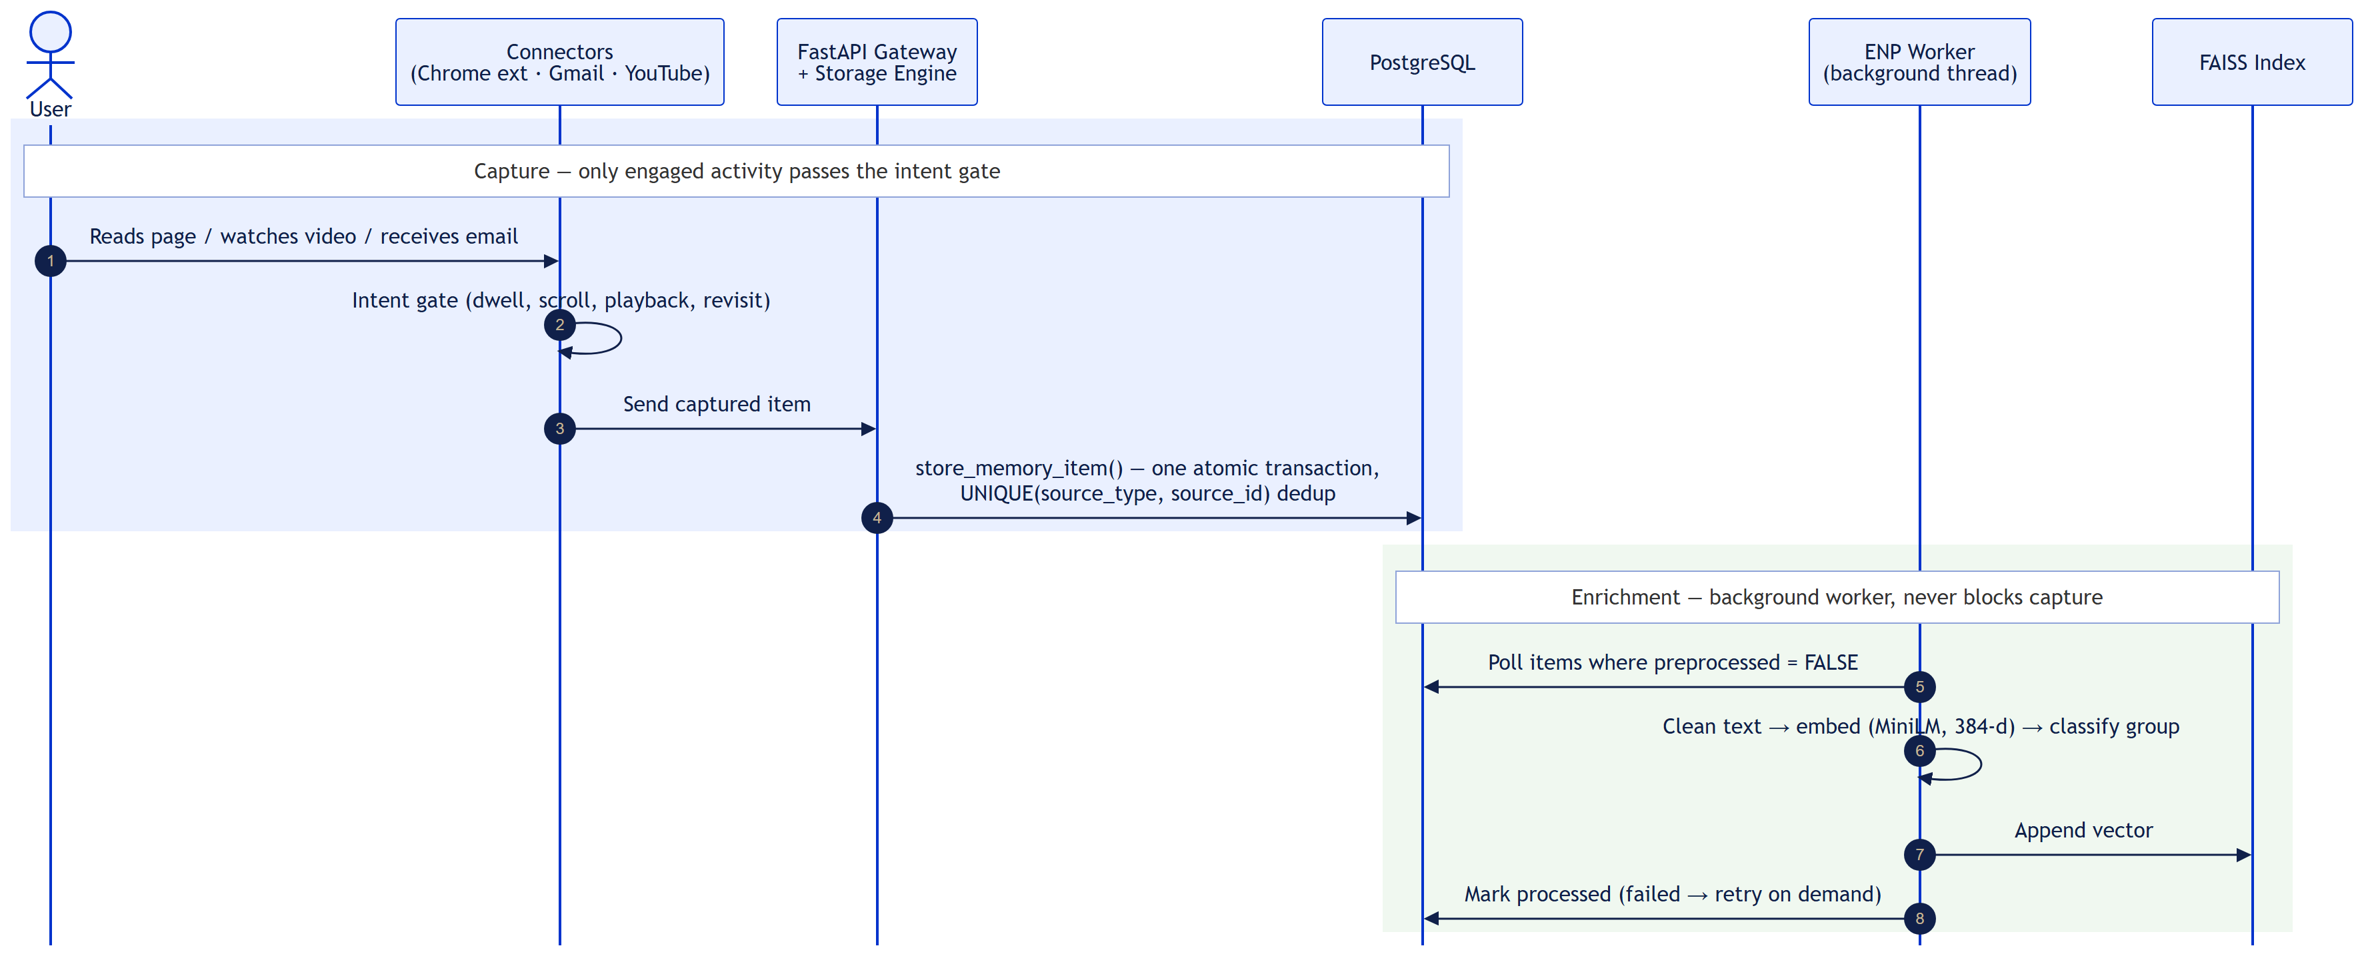
Figure 5: Sequence diagram — capture and enrichment
  - Module 2: Retrieval and Synthesis Engine (RSE)
    - Description
Module 2 answers natural-language questions about the stored memory (POST /retrieval/query). It is a LangGraph state graph with 14 nodes (rse/retrieval_engine.py). The LLM is called exactly twice per question — once to understand it and once to write the answer; every step in between is deterministic Python:
- parse_intent (LLM call 1) turns the question and the previous turns into a structured intent: sources, time filter, cleaned query, and query variants.
- resolve_time_anchor turns phrases such as "after that email" into a timestamp.
- Keyword search (PostgreSQL full-text) and semantic search (FAISS, cosine similarity) run in parallel.
- merge_and_rrf fuses both ranked lists with Reciprocal Rank Fusion (k = 60).
- evaluate_quality runs five checks; a weak or empty pool triggers widen_scope, up to three times, before no_results_found.
- rerank_cross_encoder re-scores the pool: 0.8 × cross-encoder + 0.2 × effort.
- extend_neighborhood adds same-thread or same-session context; attachment text or today's new mail is fetched only when the question asks for it.
- synthesize (LLM call 2) writes the answer from short snippets.
Conversation turns are stored in PostgreSQL (message_store), so a follow-up question can refer to the previous one. Recency boosting is deliberately not used, so older but still relevant memories are not pushed down.
    - Use Case Diagram
Level-1 use cases of the retrieval engine (the level-0 diagram is in Section 3.2.2).
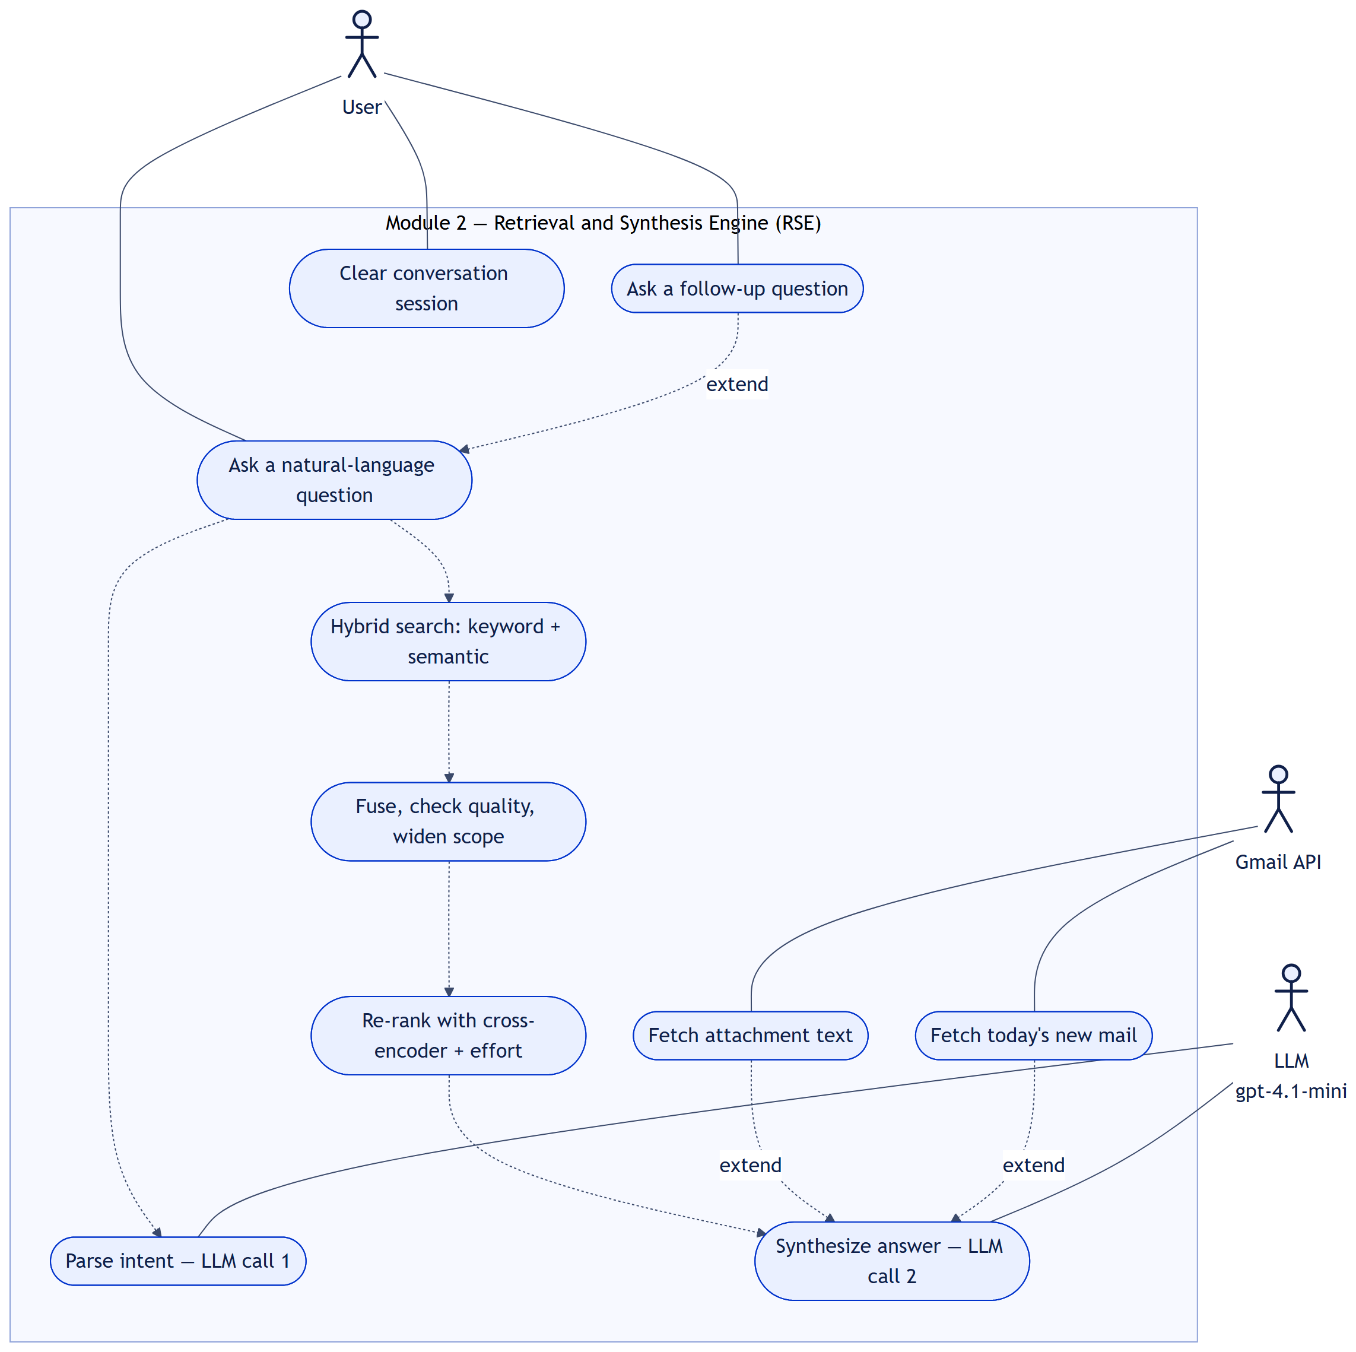
Figure 6: Level 1 — Retrieval and Synthesis Engine
Use Case Item | Description
Ask a natural-language question | For example "the Kafka article I read last week"; answered from Gmail, Chrome, and YouTube memory together.
Ask a follow-up question | Uses the earlier turns of the same session.
Parse intent — LLM call 1 | Question and history → sources, time filter, cleaned query, variants.
Hybrid search | Keyword and semantic search run in parallel.
Fuse, check quality, widen scope | RRF fusion, five quality checks, up to three widenings.
Re-rank | Cross-encoder relevance plus the user's effort on the item.
Fetch attachment text | Only when the question asks about an attachment and a top-3 result has one; the text is cached for 1 hour.
Fetch today's new mail | For "today" or "just received" questions; runs a live Gmail poll first.
Synthesize answer — LLM call 2 | Answer written from short snippets; a plain list of the top results is returned if the LLM fails.
Clear conversation session | DELETE /retrieval/session/{id} removes the session's history (requires the API key header).

    - Class Diagram
The retrieval engine and the node groups it wires together. EchoState is the single data contract passed between nodes.
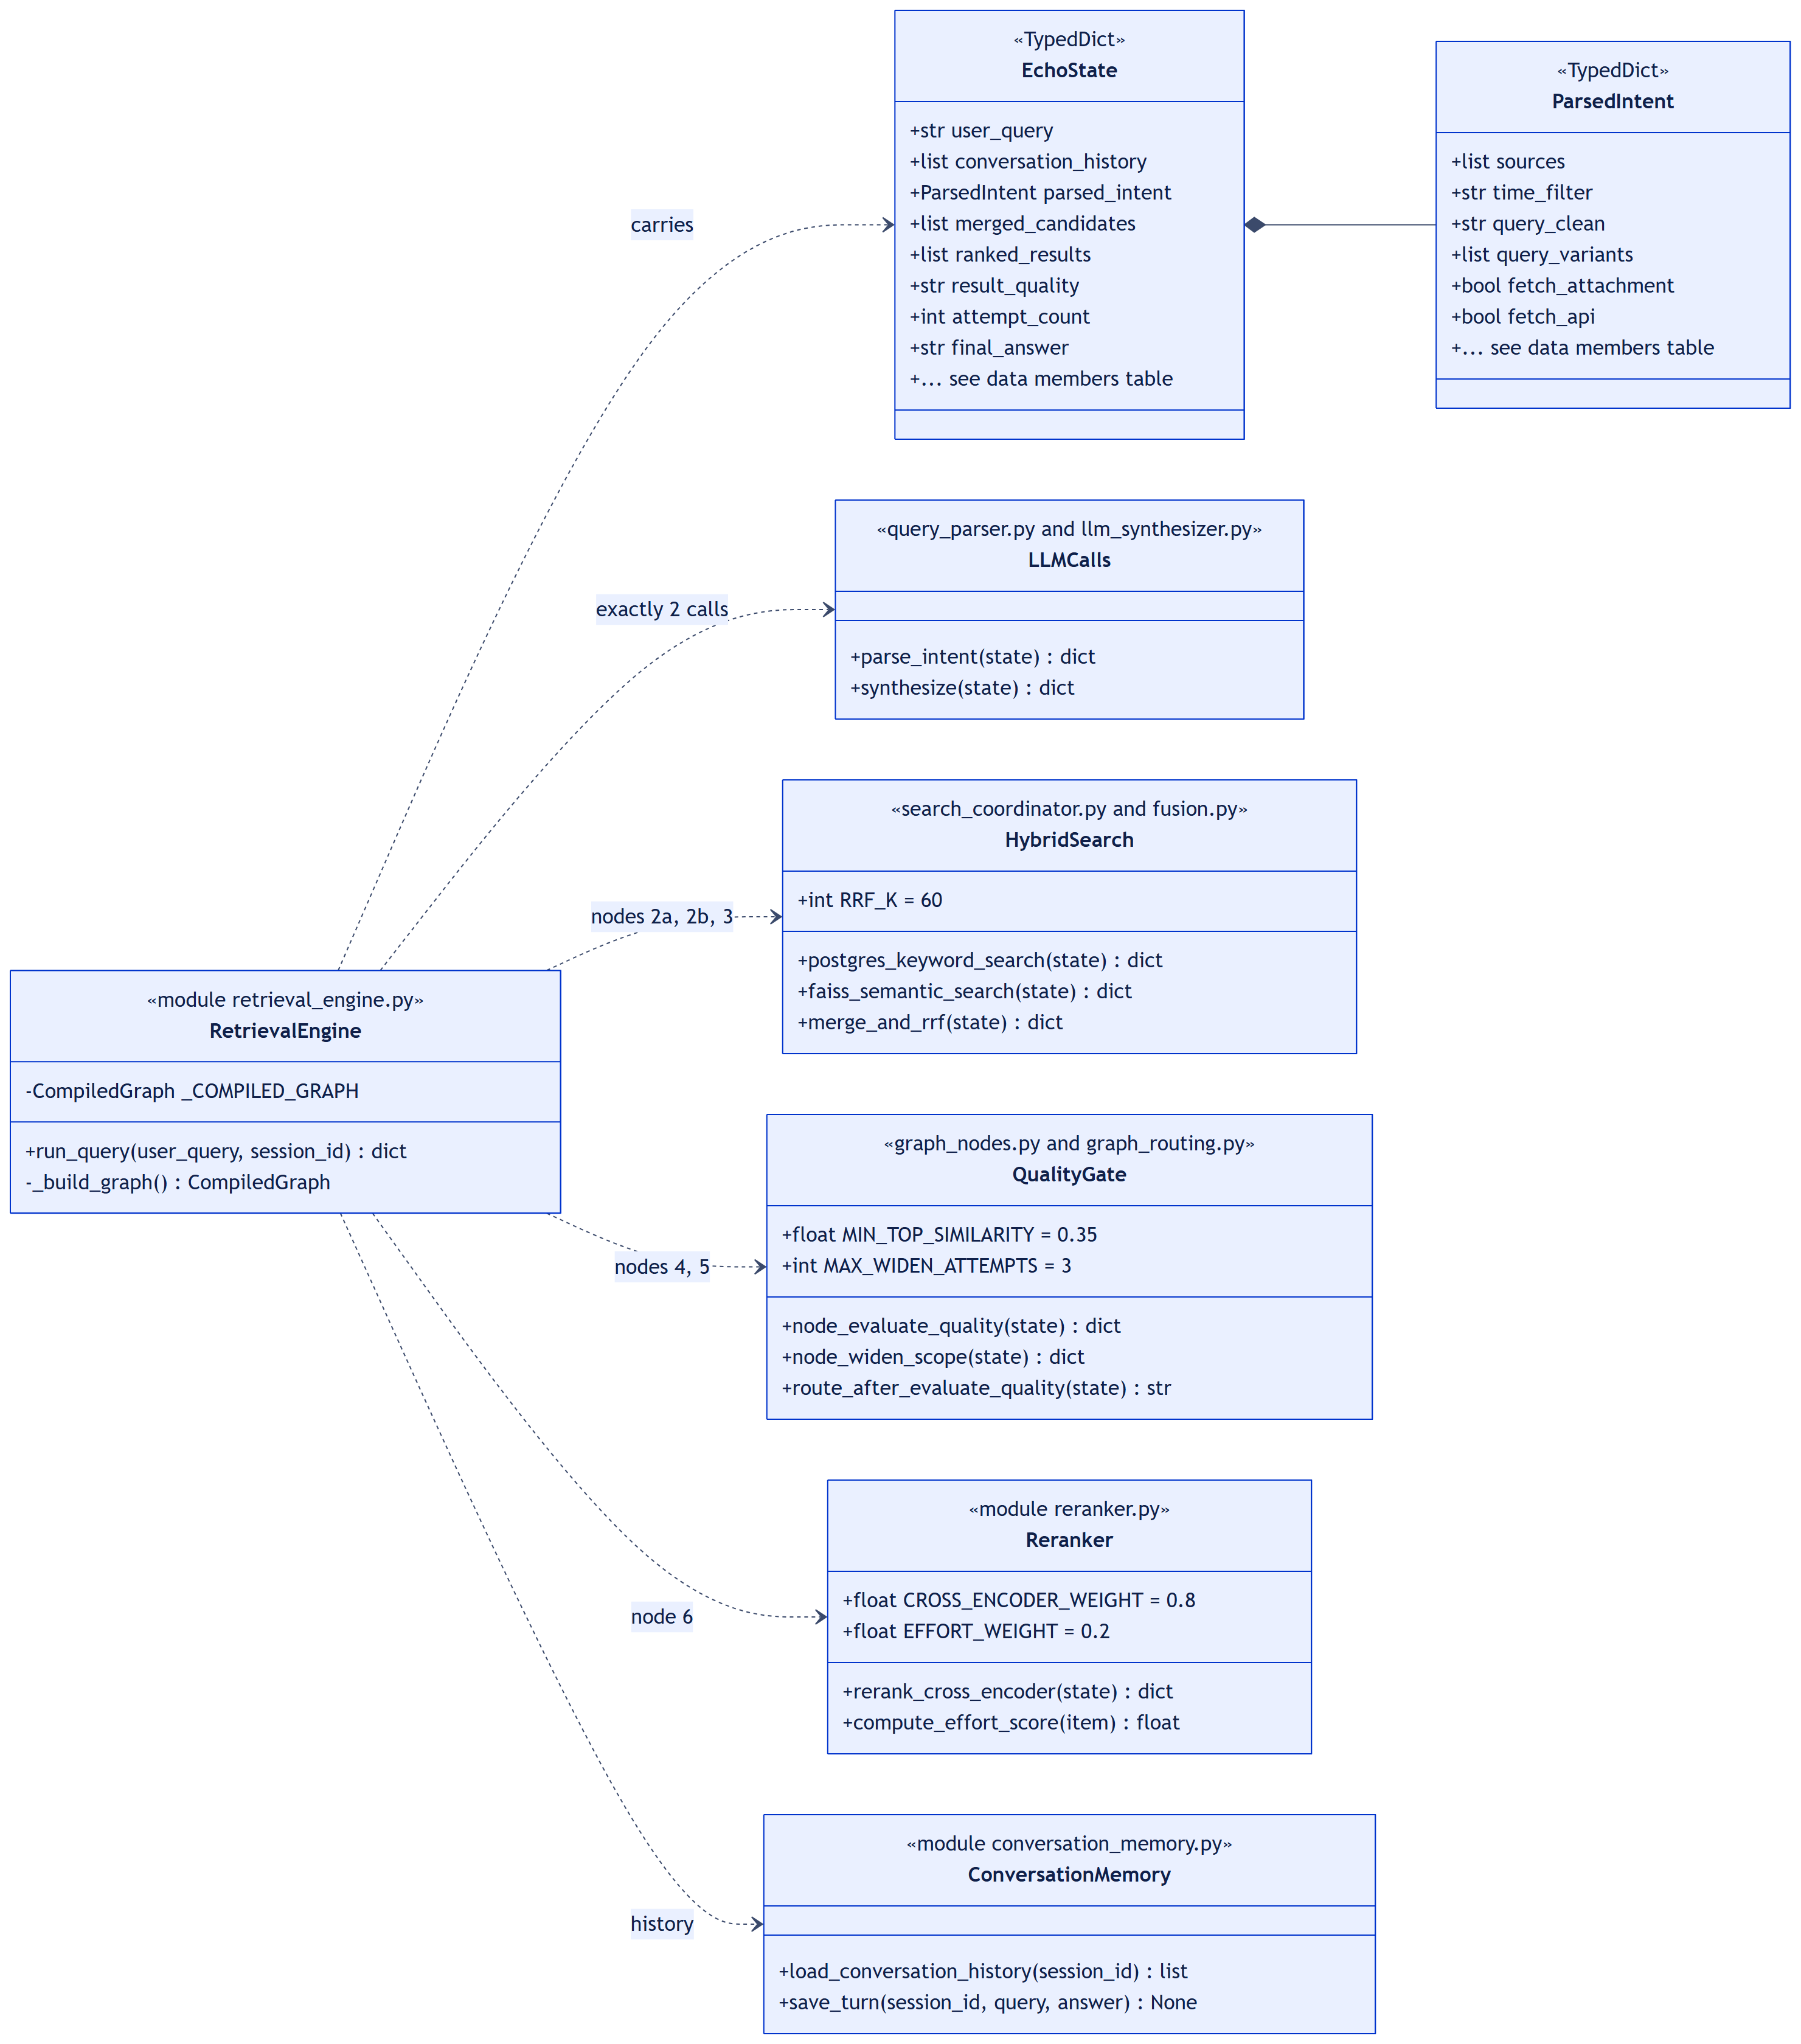
Figure 7: Class diagram — Retrieval and Synthesis Engine
      - Class Name 1: EchoState
      - Class Description 1
File: rse/state.py — a TypedDict. It carries all data between the graph nodes. Every node receives the full state and returns only the keys it changes; LangGraph merges them. It has no methods. Initial values are set by RetrievalEngine.run_query().
      - Data Members 1
Data Type | Data Name | Access Modifiers | Initial Value | Description
str | user_query | public | the question | Question as typed by the user
list[BaseMessage] | conversation_history | public | loaded | Earlier turns of this session
ParsedIntent | parsed_intent | public | {} | Output of LLM call 1
str | None | anchor_time | public | None | Resolved time anchor
dict | None | anchor_item | public | None | Item the anchor refers to
list[dict] | postgres_results | public | [] | Keyword branch, rank ordered
list[tuple] | faiss_results | public | [] | Semantic branch: (memory_id, cosine)
list[dict] | merged_candidates | public | [] | RRF-fused pool (at most 50)
list[dict] | ranked_results | public | [] | Pool after cross-encoder re-ranking
dict | neighbor_items | public | {} | Context items per top result
str | None | attachment_content | public | None | Extracted attachment text, when asked
list[dict] | api_results | public | [] | Today's fresh items, when asked
str | result_quality | public | "empty" | strong / weak / empty
int | attempt_count | public | 0 | Widen-scope attempts so far (max 3)
str | final_answer | public | "" | Answer returned to the user
bool | no_results | public | False | True when nothing relevant was found

      - Class Name 2: ParsedIntent
      - Class Description 2
File: rse/state.py — a TypedDict produced by LLM call 1 and repaired by _normalise_intent() so later nodes never see malformed values. If parsing fails, a safe fallback intent searches all sources with the question as typed. It has no methods; widen_scope edits it between search attempts.
      - Data Members 2
Data Type | Data Name | Access Modifiers | Initial Value | Description
list[str] | sources | public | all three | gmail, chrome, youtube
str | None | time_filter | public | None | Earliest date to include (ISO)
bool | fetch_attachment | public | False | Question asks about an attachment
bool | fetch_api | public | False | Question asks about today's new items
str | query_clean | public | the question | Question without filler words
list[str] | query_variants | public | [question] | Rephrasings for semantic search
str | None | time_anchor_query | public | None | Phrase naming the anchor item
str | None | time_relation | public | None | before / after the anchor
int | scope_level | public | 0 | Reserved; currently always 0
bool | is_ambiguous | public | True (fallback) | Parser was unsure
str | original_query | public | the question | Unmodified question
bool | skip_postgres_filter | public | False | Set by widen attempt 3
bool | full_faiss_scan | public | False | Set by widen attempt 3 (k × 3)

      - Class Name 3: RetrievalEngine
      - Class Description 3
File: rse/retrieval_engine.py. Builds and compiles the LangGraph once when the module is imported, and runs it for each question. It loads the conversation history before the run and saves the new turn after it. Its constants are defined in rse/config.py.
      - Data Members 3
Data Type | Data Name | Access Modifiers | Initial Value | Description
CompiledGraph | _COMPILED_GRAPH | private | _build_graph() | The compiled 14-node graph, reused for every query
int | MAX_WIDEN_ATTEMPTS | public, constant | 3 | Widenings before no_results_found
int | CONVERSATION_HISTORY_DAYS | public, constant | 30 | Age used by the cleanup helper cleanup_old_sessions() (run manually)

      - Method 1: run_query()
- Purpose: Answer one question; the entry point used by POST /retrieval/query.
- Input: The question and an optional session id.
- Output: Final EchoState plus session_id and result_count.
- Parameters: user_query: str, session_id: str | None = None
- Exceptions: Any error inside the graph is caught: the answer becomes an error message and no_results = True, so the API always responds.
- Pseudo-code:
if no session_id: session_id = new uuid
history = load_conversation_history(session_id)
state = initial EchoState(user_query, history)
try: final = _COMPILED_GRAPH.invoke(state)
except error: final = state with error answer, no_results = True
if final.final_answer: save_turn(session_id, user_query, answer)
return final + session_id + result_count
      - Method 2: _build_graph()
- Purpose: Register the 14 nodes and their edges.
- Input: None.
- Output: A compiled LangGraph.
- Parameters: None.
- Exceptions: LangGraph raises at import time if the graph is wired incorrectly.
- Pseudo-code:
parse_intent -> resolve_time_anchor
resolve_time_anchor -> keyword_search AND semantic_search # parallel
both -> merge_and_rrf -> evaluate_quality
evaluate_quality: strong -> rerank_cross_encoder
weak/empty, attempts < 3 -> widen_scope -> searches
otherwise -> no_results_found -> END
rerank -> extend_neighborhood -> check_attachments
check_attachments -> fetch_attachment | fetch_api | synthesize
synthesize -> END
      - Class Name 4: HybridSearch
      - Class Description 4
Files: rse/search_coordinator.py and rse/fusion.py. The two search branches and their fusion. The keyword branch uses PostgreSQL full-text search with an ILIKE fallback on title, subject, sender, domain, channel, and keywords. The semantic branch embeds each query variant locally and searches the full FAISS index, scoring hits by true cosine similarity. A failure in one branch returns an empty list, so the other branch still answers. Constants are defined in rse/config.py.
      - Data Members 4
Data Type | Data Name | Access Modifiers | Initial Value | Description
int | PG_KEYWORD_LIMIT | public, constant | 200 | Keyword candidates per search
int | FAISS_TOP_K_PER_VARIANT | public, constant | 30 | Semantic hits per query variant
int | FULL_SCAN_K_MULTIPLIER | public, constant | 3 | k multiplier on widen attempt 3
int | RRF_K | public, constant | 60 | Reciprocal Rank Fusion constant
int | RRF_POOL_SIZE | public, constant | 50 | Fused candidates kept for re-ranking

      - Method 1: postgres_keyword_search()
- Purpose: Keyword branch (node 2a).
- Input: EchoState with the parsed intent and anchor time.
- Output: {postgres_results: [...]} ordered by full-text rank.
- Parameters: state: EchoState
- Exceptions: Database errors are logged and return an empty list.
- Pseudo-code:
if skip_postgres_filter or no keyword:
return most recently accessed items (limit 1000)
where = not deleted AND processed AND source / time / anchor filters
match = full-text(query_clean) OR ILIKE on title, subject, sender,
domain, channel, keywords
return rows ordered by ts_rank, limit 200
      - Method 2: faiss_semantic_search()
- Purpose: Semantic branch (node 2b) with query expansion.
- Input: EchoState with the query variants.
- Output: {faiss_results: [(memory_id, cosine), ...]}, best first.
- Parameters: state: EchoState
- Exceptions: Index or model errors are logged and return an empty list.
- Pseudo-code:
variants = query_variants or [query_clean]
k = 30 (x3 when full_faiss_scan)
for vector in embed(variants): # local model, no API call
for hit in FAISS top-k: keep best cosine per memory_id
return hits sorted by cosine
      - Method 3: merge_and_rrf()
- Purpose: Fuse the two ranked lists (node 3).
- Input: EchoState with both branch results.
- Output: {merged_candidates: [...]} — at most 50, with rrf_score, ranks, and similarity.
- Parameters: state: EchoState
- Exceptions: None; empty branches give an empty pool.
- Pseudo-code:
for each branch, for rank, item: score[item] += 1 / (60 + rank)
load full rows for semantic-only hits; re-apply source and time filters
sort by score, keep the top 50
      - Class Name 5: QualityGate
      - Class Description 5
Files: rse/graph_nodes.py and rse/graph_routing.py. Decides whether the fused pool is good enough, and if not, how to widen the search. It makes no LLM call. After three widenings a weak or empty pool ends in no_results_found, so the engine says so honestly instead of guessing. Constants are defined in rse/config.py.
      - Data Members 5
Data Type | Data Name | Access Modifiers | Initial Value | Description
float | MIN_TOP_SIMILARITY | public, constant | 0.35 | Best cosine below this → weak
int | MIN_RESULT_COUNT | public, constant | 2 | Fewer candidates → weak
int | MAX_WIDEN_ATTEMPTS | public, constant | 3 | Widenings before giving up

      - Method 1: node_evaluate_quality()
- Purpose: Grade the fused pool as strong, weak, or empty (node 4).
- Input: EchoState with merged_candidates and parsed_intent.
- Output: {result_quality: "strong" | "weak" | "empty"}.
- Parameters: state: EchoState
- Exceptions: An unparseable time filter skips check 3 with a warning.
- Pseudo-code:
if pool is empty: return empty
if a source was requested and none in pool: return empty
if a time filter is set and nothing inside it: return weak
if fewer than 2 candidates: return weak
if best cosine similarity < 0.35: return weak
return strong
      - Method 2: node_widen_scope()
- Purpose: Relax one dimension of the search and loop back to both branches (node 5).
- Input: EchoState with attempt_count and parsed_intent.
- Output: Updated parsed_intent and attempt_count + 1.
- Parameters: state: EchoState
- Exceptions: None.
- Pseudo-code:
attempt 1: widen time window by 4 days, or open all sources,
or trim the query to its core keyword
attempt 2: drop time filter and anchor; all sources; core keyword only
attempt 3: skip keyword filters; full FAISS scan (k x 3)
      - Class Name 6: Reranker
      - Class Description 6
File: rse/reranker.py. Re-scores the fused pool against the actual question with a local cross-encoder (ms-marco-MiniLM-L-6-v2), and adds how much effort the user put into each item. There is no recency term by design. If the model cannot load, ranking falls back to RRF position plus effort, so retrieval never fails on a model problem. The model name and weights are defined in rse/config.py.
      - Data Members 6
Data Type | Data Name | Access Modifiers | Initial Value | Description
str | CROSS_ENCODER_MODEL | public, constant | cross-encoder/ ms-marco-MiniLM-L-6-v2 | Local re-ranking model
float | CROSS_ENCODER_WEIGHT | public, constant | 0.8 | Weight of relevance
float | EFFORT_WEIGHT | public, constant | 0.2 | Weight of user effort
int | RERANK_DOC_CHAR_LIMIT | public, constant | 512 | Characters of each item scored
int | _DWELL_CEILING_SECONDS, _REVISIT_CEILING, _INTERACTION_CEILING | private, constant | 600, 5, 10 | Values at which each effort signal reaches 1.0

      - Method 1: rerank_cross_encoder()
- Purpose: Produce the final ranking (node 6).
- Input: EchoState with merged_candidates and user_query.
- Output: {ranked_results: [...]} with ce_score, effort_score, and final_score.
- Parameters: state: EchoState
- Exceptions: A model or scoring error is logged; ranking falls back to RRF order plus effort.
- Pseudo-code:
pairs = (question, title + subject + snippet) for each candidate
relevance = sigmoid(cross_encoder.predict(pairs))
for each candidate:
final = 0.8 x relevance + 0.2 x compute_effort_score(candidate)
sort by final score, highest first
      - Method 2: compute_effort_score()
- Purpose: Measure how much attention the user gave an item, from 0 to 1.
- Input: One candidate with its engagement fields.
- Output: Mean of the available signals.
- Parameters: item: dict
- Exceptions: None; an item never opened scores 0.
- Pseudo-code:
signals = [min((dwell + watch time) / 600, 1)]
add scroll depth, revisits / 5, interactions / 10, completion rate
(each capped at 1, only when present for that source)
return average(signals)
      - Class Name 7: LLMCalls
      - Class Description 7
Files: rse/query_parser.py and rse/llm_synthesizer.py — the only two places the retrieval engine calls the LLM. The provider is plug-and-play through LLM_CONFIG in rse/config.py; it is currently OpenAI gpt-4.1-mini. Both calls have a deterministic fallback, so an LLM outage never loses the retrieval work.
      - Data Members 7
Data Type | Data Name | Access Modifiers | Initial Value | Description
str | LLM_CONFIG["provider"] | public, constant | "openai" | Swappable in one place
str | parser_model, synthesizer_model | public, constant | gpt-4.1-mini | Models for call 1 and call 2
float | parser_temperature, synthesizer_temperature | public, constant | 0.0, 0.3 | Strict JSON for parsing; natural prose for answers
int | max_retries | public, constant | 2 | Fail fast instead of long retry loops
int | SYNTHESIS_TOP_RESULTS | public, constant | 10 | Results given to call 2
int | SNIPPET_CHAR_LIMIT | public, constant | 500 | Characters of text per result

      - Method 1: parse_intent()
- Purpose: LLM call 1: turn the question into a ParsedIntent (node 1).
- Input: EchoState with user_query and conversation_history.
- Output: {parsed_intent: ParsedIntent}.
- Parameters: state: EchoState
- Exceptions: Invalid JSON or an LLM error returns the fallback intent (all sources, question as typed).
- Pseudo-code:
prompt = today's date + history + few-shot examples + question
reply = LLM(prompt) # LLM call 1
strip code fences; parsed = json.loads(reply)
return _normalise_intent(parsed) # repairs bad fields
      - Method 2: synthesize()
- Purpose: LLM call 2: write the answer from the ranked results (node 10).
- Input: EchoState with ranked_results, neighbours, attachment text, fresh items, and history.
- Output: {final_answer, no_results: False}.
- Parameters: state: EchoState
- Exceptions: An LLM error returns a readable list of the top results instead of an error.
- Pseudo-code:
blocks = top 10 results: source, date, 500-char snippet, neighbours
add attachment text and today's items when present
answer = LLM(question + history + blocks) # LLM call 2
return answer
    - Sequence Diagram
One question from the user to the answer. The LLM appears exactly twice; the hybrid search, fusion, quality loop, and re-ranking run locally.
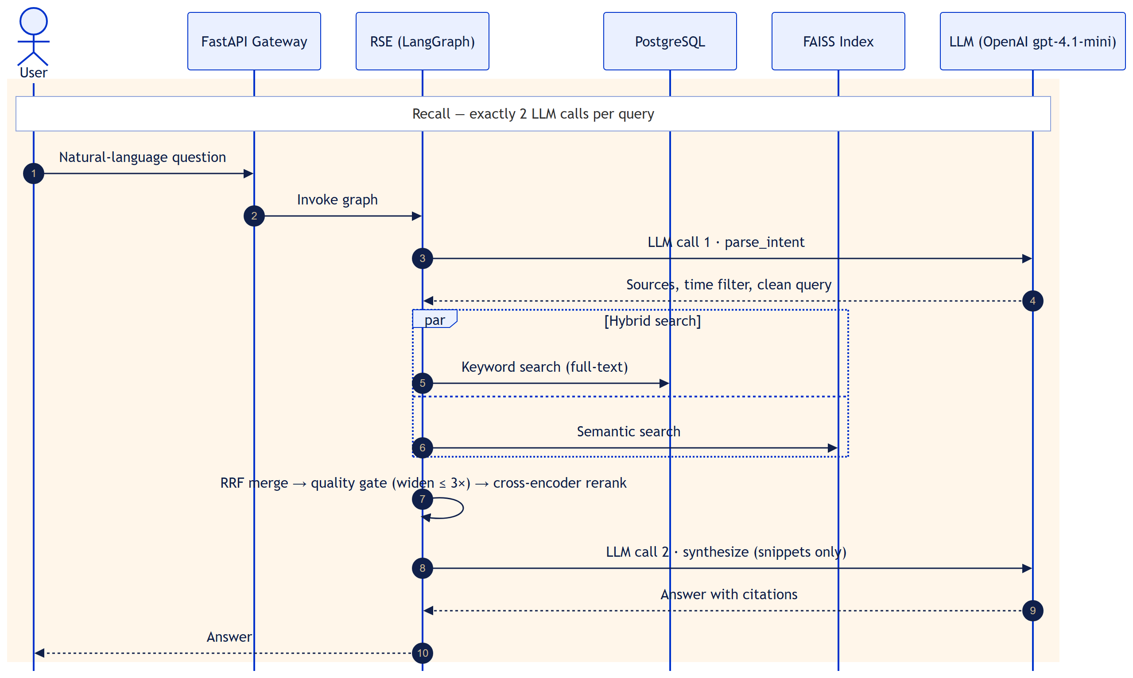
Figure 8: Sequence diagram — recall with exactly 2 LLM calls
  - Module 3: Digital Wellbeing and Analytics (WBA)
    - Description
Module 3 reflects on how time is spent, without judging it. Time totals are computed on demand from engagement data (wba/); sessions are stored when a rebuild is requested (manually or by an OS scheduler), and its API is mounted under /wellbeing when ECHO_WBA_ENABLED=1. The module is implemented; validation on live data is scheduled in October.
- Time: totals per day, per system group, and per source. Only opened emails, admitted pages, and watched videos count; Shorts are reported separately.
- Sessions: items less than 5 minutes apart form one session. Focus = 1 / number of distinct sources in the session; fragmentation = sessions per day / average session length in minutes.
- Regret: the user marks an item as regretted. Each mark or unmark is a new row, and an odd count means regretted. Gentle reminders repeat only the user's own note, at most 2 per day.
- User groups: the user creates groups (for example "Placement preparation") and rules. Once a group has 6 confirmed items, new items are scored with 0.5 × rule score + 0.5 × KNN score and become pending suggestions; an item joins a group only when the user accepts it.
- Weekly insight: a short, descriptive reflection written by the LLM from aggregated numbers only.
Wellbeing language is descriptive — there are no scores and no "wasted time" phrasing.
    - Use Case Diagram
Level-1 use cases of the wellbeing module (the level-0 diagram is in Section 3.2.2).
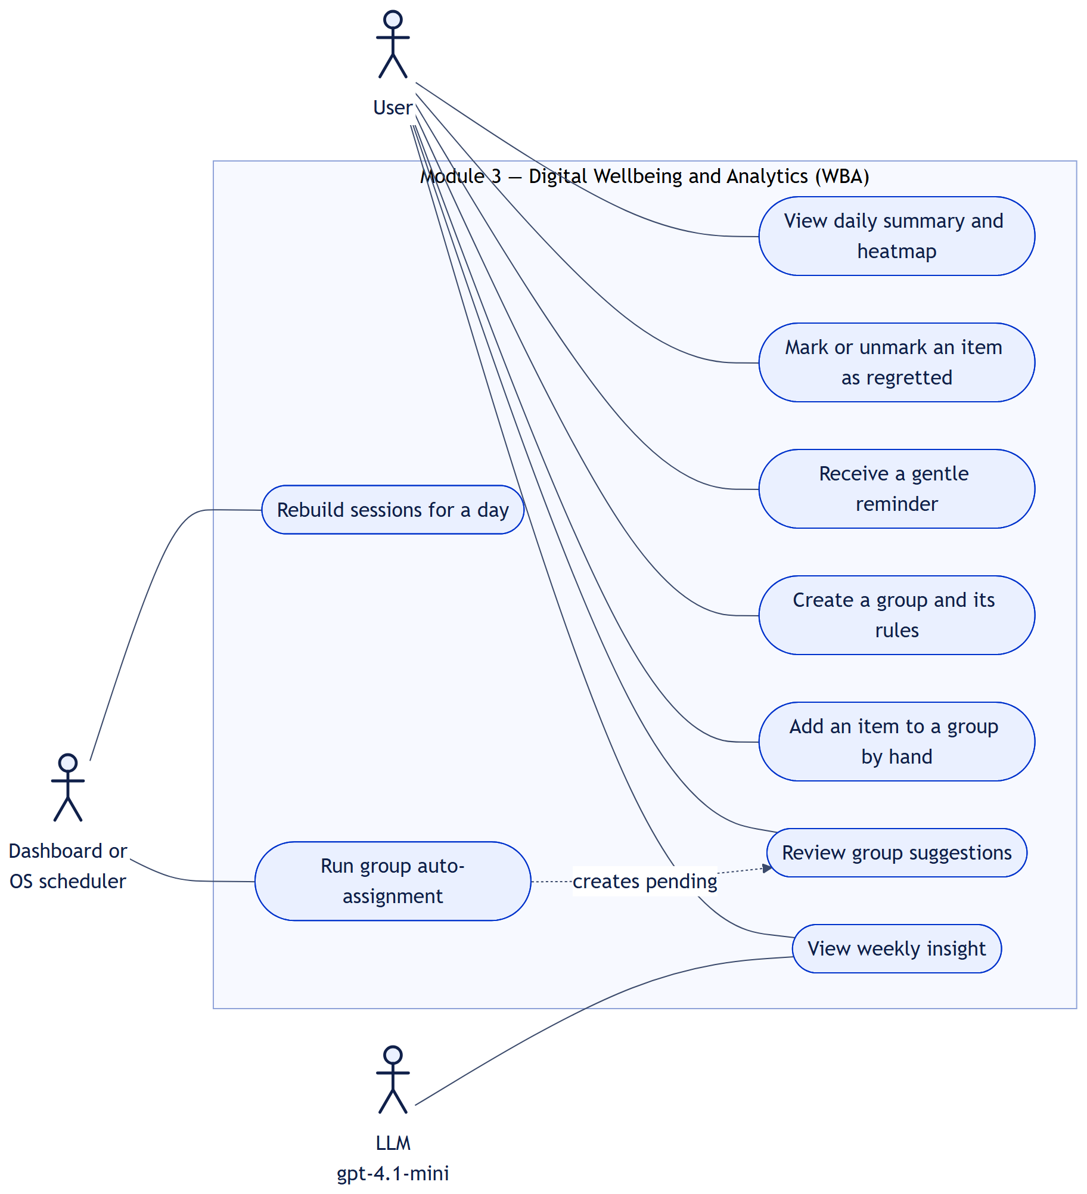
Figure 9: Level 1 — Digital Wellbeing and Analytics
Use Case Item | Description
View daily summary and heatmap | GET /wellbeing/analytics/daily and /analytics/heatmap: time, categories, Shorts, regret rate, sessions.
Mark or unmark an item as regretted | POST /wellbeing/regret/{memory_id}, with an optional note.
Receive a gentle reminder | Only when the session is at least 15 minutes, a habitual pattern exists, and daily limits allow; reminders can be turned off.
Create a group and its rules | Rules by keyword, domain, channel, sender, or date range.
Add an item to a group by hand | POST /wellbeing/groups/{id}/assign — the user's action is the approval.
Review group suggestions | GET /wellbeing/groups/review, then accept or reject each suggestion.
View weekly insight | GET /wellbeing/insights/weekly.
Rebuild sessions for a day | POST /wellbeing/sessions/rebuild — recomputes that day's sessions.
Run group auto-assignment | POST /wellbeing/groups/auto-assign — creates pending suggestions only.

    - Class Diagram
The wellbeing classes. TimeAggregator and PatternDetector provide the numbers that the other classes describe.
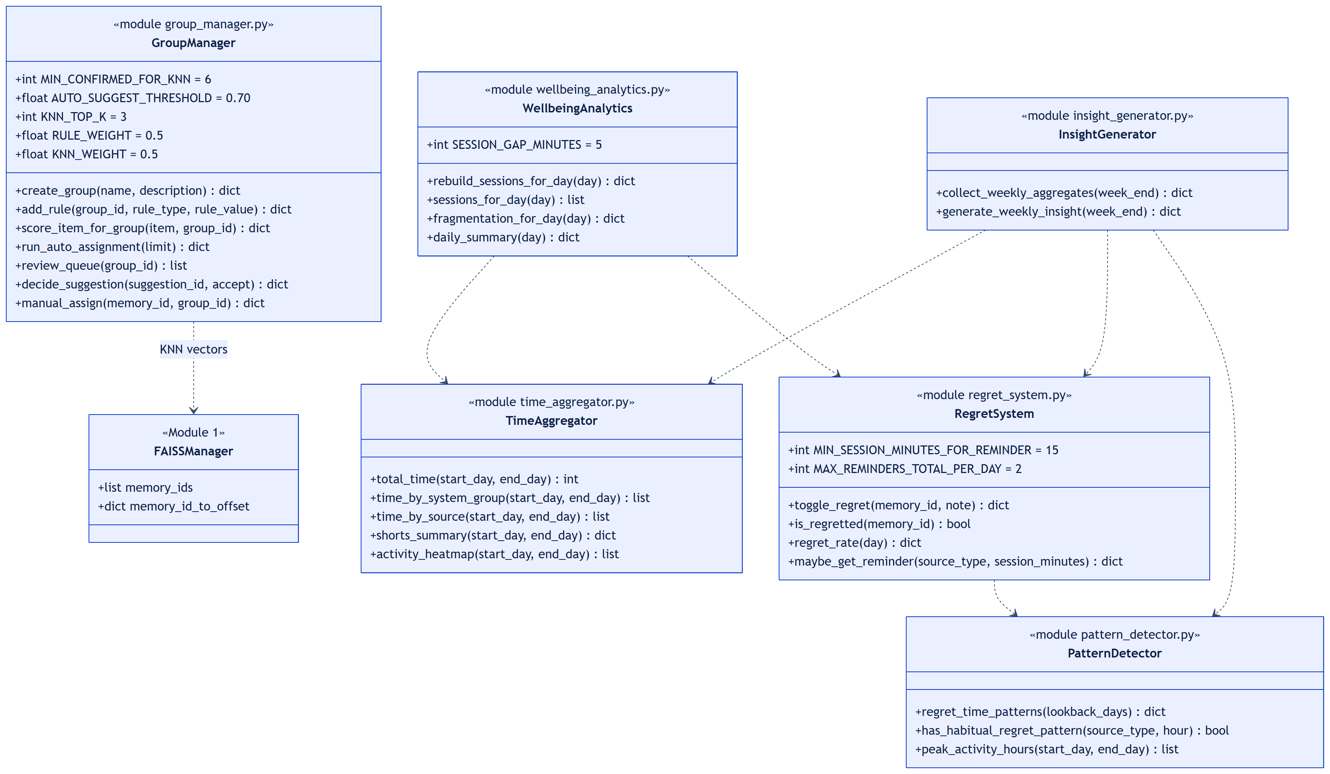
Figure 10: Class diagram — Digital Wellbeing and Analytics
      - Class Name 1: WellbeingAnalytics
      - Class Description 1
Files: wba/wellbeing_analytics.py with wba/time_aggregator.py. Computes sessions and the daily summary that the dashboard shows. Time totals are never stored — they are summed from memory_engagement on request, which avoids double counting. Sessions are stored by rebuild_sessions_for_day(), so the daily summary shows sessions only after a rebuild for that day.
      - Data Members 1
Data Type | Data Name | Access Modifiers | Initial Value | Description
int | SESSION_GAP_MINUTES | public, constant | 5 | A longer gap closes a session
str | _TIME_UNION | private, constant | SQL | One query per source, each with its own inclusion rule

      - Method 1: rebuild_sessions_for_day()
- Purpose: Recompute and store the sessions of one day. Safe to run again.
- Input: A calendar day.
- Output: {day, sessions, items} counts.
- Parameters: day: date
- Exceptions: A database error rolls back the transaction, so the previous sessions stay intact.
- Pseudo-code:
items = engaged items of the day, ordered by activity time
sessions = split items wherever the gap is more than 5 minutes
begin transaction
delete that day's sessions
for each session: insert start, end, total time, dominant group,
source switches; map its items
commit
      - Method 2: daily_summary()
- Purpose: Everything the Daily Summary view needs, in one call.
- Input: A day (defaults to today).
- Output: Total time, time by group and by source, Shorts, regret rate, and session fragmentation.
- Parameters: day: date | None = None
- Exceptions: Database errors propagate to the API (HTTP 500).
- Pseudo-code:
return {
total_seconds: TimeAggregator.total_time(day, day),
by_system_group, by_source, shorts,
regret: regret_rate(day),
sessions: fragmentation_for_day(day) # sessions / avg minutes
}
      - Class Name 2: GroupManager
      - Class Description 2
File: wba/group_manager.py. User groups with a hybrid rule-plus-KNN engine and human-in-the-loop approval. It is the only code that writes memory_user_groups, and it writes only through group_suggestions with an accepted decision. Adding an item by hand records an accepted suggestion in the same transaction, so the audit trail stays complete.
      - Data Members 2
Data Type | Data Name | Access Modifiers | Initial Value | Description
int | MIN_CONFIRMED_FOR_KNN | public, constant | 6 | Confirmed items before auto-suggestions start
float | AUTO_SUGGEST_THRESHOLD | public, constant | 0.70 | Hybrid score needed to suggest
int | KNN_TOP_K | public, constant | 3 | Most similar members averaged
float | RULE_WEIGHT, KNN_WEIGHT | public, constant | 0.5, 0.5 | Hybrid score weights
int | AUTO_ASSIGN_BATCH_LIMIT | public, constant | 200 | Recent items scored per run
set[str] | VALID_RULE_TYPES | public, constant | 5 types | keyword, domain, channel, sender, time_window

      - Method 1: score_item_for_group()
- Purpose: Hybrid score of one item against one group.
- Input: An item and a group id.
- Output: {rule_score, knn_score, final_score}, or None while the group has fewer than 6 members.
- Parameters: item: dict, group_id: str
- Exceptions: If FAISS is unavailable the KNN score is 0 and the rules still apply.
- Pseudo-code:
members = confirmed items of the group
if len(members) < 6: return None
rule = rules matched / total rules # count each match
knn = mean cosine of the 3 most similar members
return rule, knn, 0.5 x rule + 0.5 x knn
      - Method 2: run_auto_assignment()
- Purpose: Create pending suggestions for recent items. Nothing is auto-accepted.
- Input: How many recent items to score.
- Output: {scored, suggested} counts.
- Parameters: limit: int = 200
- Exceptions: Database errors propagate to the caller.
- Pseudo-code:
for item in recent processed items:
for group with 6+ confirmed members:
skip if already a member or already suggested
s = score_item_for_group(item, group)
if s.final > 0.70 or s.rule > 0:
insert suggestion with decision = 'pending'
      - Method 3: decide_suggestion()
- Purpose: Record the user's accept or reject decision — the only path into a group.
- Input: A suggestion id and the decision.
- Output: {suggestion_id, decision}.
- Parameters: suggestion_id: str, accept: bool
- Exceptions: ValueError if the suggestion does not exist; the transaction then rolls back.
- Pseudo-code:
begin transaction
mark suggestion accepted or rejected, reviewed = TRUE
if accepted: insert (memory_id, group_id) into memory_user_groups
else: remove that membership if present
commit
      - Class Name 3: RegretSystem
      - Class Description 3
File: wba/regret_system.py. Records the user's own regret marks and offers optional, rate-limited reminders. E.C.H.O. never decides what is regretful. Rows are only ever inserted, never updated or deleted, so the full history is kept. Reminder limits live in Redis.
      - Data Members 3
Data Type | Data Name | Access Modifiers | Initial Value | Description
int | MIN_SESSION_MINUTES_FOR_REMINDER | public, constant | 15 | Session length before a reminder
int | MAX_REMINDERS_PER_TYPE_PER_DAY | public, constant | 1 | Per content type
int | MAX_REMINDERS_TOTAL_PER_DAY | public, constant | 2 | Across all types
int | REMINDER_COOLDOWN_SECONDS | public, constant | 7200 | Two hours between reminders
str | _DISABLED_KEY | private, constant | echo:regret:reminders:disabled | Set when the user turns reminders off

      - Method 1: toggle_regret()
- Purpose: Mark an item as regretted, or unmark it (POST /wellbeing/regret/{memory_id}).
- Input: A memory id and an optional note.
- Output: {memory_id, regretted, marked_at}.
- Parameters: memory_id: str, note: str | None = None
- Exceptions: ValueError (HTTP 404) when the item does not exist or is deleted.
- Pseudo-code:
if item does not exist: raise ValueError
insert regret_events row (time, note, hour, day of week)
regretted = (number of rows for the item) is odd
return regretted
      - Method 2: maybe_get_reminder()
- Purpose: Return a gentle reminder only when every condition holds.
- Input: The current content type and session length.
- Output: {source_type, your_note, options} or None.
- Parameters: source_type: str, current_session_minutes: int
- Exceptions: Without Redis, reminders are off (returns None). Database errors propagate (HTTP 500).
- Pseudo-code:
if reminders disabled or Redis unavailable: return None
if session < 15 minutes: return None
if no habitual regret pattern at this hour: return None
if cooldown active, or type limit (1) or daily limit (2) reached:
return None
note = user's latest note for this type; if none: return None
record usage in Redis; return the user's own note
      - Class Name 4: InsightGenerator
      - Class Description 4
File: wba/insight_generator.py. Writes the weekly reflection. Only aggregated numbers reach the LLM — totals per category, regret counts, session patterns, peak hours, and Shorts statistics — never email subjects, page titles, URLs, or video titles. The prompt forbids judging or advice; if the LLM fails, a deterministic summary is returned.
      - Data Members 4
Data Type | Data Name | Access Modifiers | Initial Value | Description
str | _INSIGHT_PROMPT | private, constant | prompt text | Descriptive-only rules for the LLM

      - Method 1: generate_weekly_insight()
- Purpose: Weekly aggregates plus a short reflection (GET /wellbeing/insights/weekly).
- Input: The last day of the week (defaults to today).
- Output: {aggregates, reflection, generated_by: "llm" | "deterministic"}.
- Parameters: week_end: date | None = None
- Exceptions: Any LLM error falls back to the deterministic summary.
- Pseudo-code:
aggregates = collect_weekly_aggregates(week_end) # numbers only
try: reflection = LLM(descriptive prompt + aggregates)
except error: reflection = deterministic summary
return aggregates, reflection
    - Sequence Diagram
Opening the wellbeing views. The analytics are computed from PostgreSQL; the LLM sees aggregated numbers only, and group suggestions wait for the user's decision.
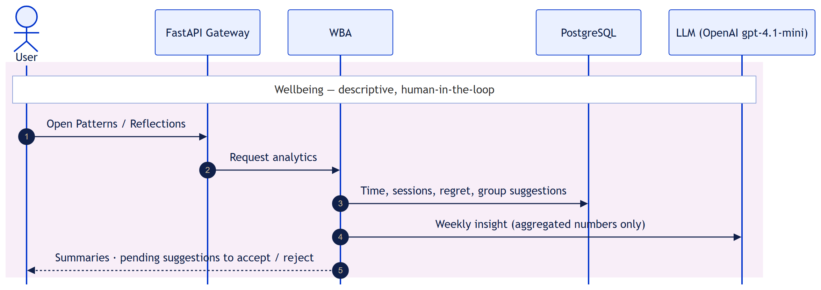
Figure 11: Sequence diagram — wellbeing analytics
  - Packaging and Deployment Diagram
E.C.H.O. runs on the user's laptop. The Chrome extension and the React dashboard talk to one FastAPI process on port 8000 over HTTP JSON. That process hosts every Python package and runs the enrichment worker as a background thread. During development PostgreSQL is hosted on Neon so the four team members can work in parallel; the design target is a local database.
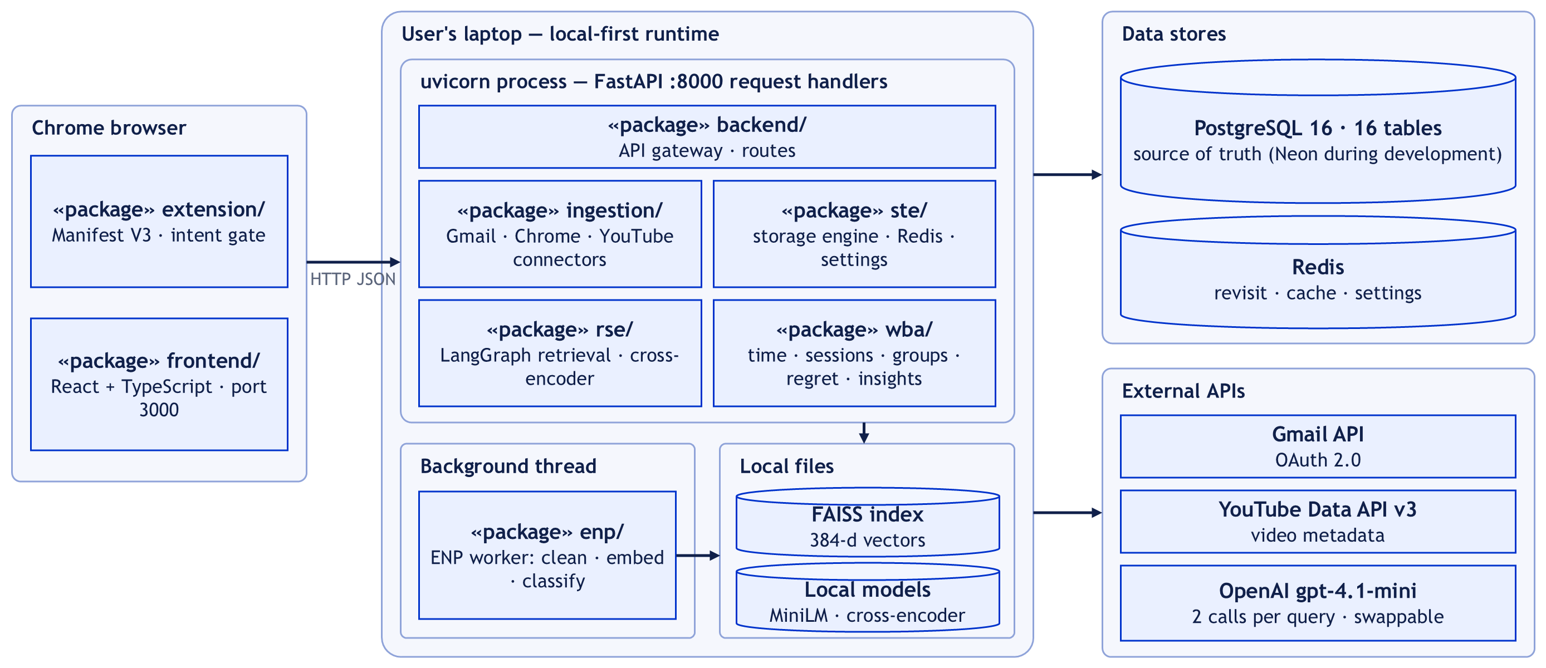
Figure 12: Packaging and deployment diagram
Package | Contents | Runs in
extension/ | Manifest V3 extension: Chrome, YouTube, and Gmail trackers, intent gate; all capture traffic goes through one function, postToBackend() | Chrome browser
frontend/ | React + TypeScript dashboard (Vite, port 3000) | Browser
backend/ | FastAPI app, routers, CORS, /health; starts the Gmail poller and the enrichment thread | uvicorn, port 8000
ingestion/ | Gmail, Chrome, and YouTube connectors | uvicorn
ste/ | Storage engine; PostgreSQL, Redis, and FAISS managers; settings; token encryption | uvicorn
enp/ | Enrichment worker, classifier, embeddings, attachment extraction | Background thread in uvicorn
rse/ | LangGraph retrieval and synthesis engine | uvicorn
wba/ | Wellbeing analytics | uvicorn (when ECHO_WBA_ENABLED=1)
Data stores | PostgreSQL 16 (16 tables), Redis, FAISS index file, local models | Laptop / Neon during development

Proposed Methodology / Approach
The basic approach of E.C.H.O.:
- Capture only engaged activity (intent gates).
- Store atomically in PostgreSQL — the source of truth.
- Enrich in the background: clean → embed → classify.
- Answer with hybrid search and exactly 2 LLM calls.
- Reflect on time use — descriptive, never judgmental.
  - Algorithm and Pseudocode
Algorithm 1 — Hybrid retrieval with a self-correcting loop
The retrieval engine combines keyword and semantic search, checks the quality of what it found, and widens the search when needed. Only the first and last steps use the LLM.
function answer(question, history):
intent = LLM.parse_intent(question, history) # LLM call 1
intent = resolve_time_anchor(intent) # 'after that email' -> date
attempts = 0
loop:
in parallel:
kw = postgres_fulltext_search(intent)
sem = faiss_search(embed(intent.query))
pool = RRF(kw, sem) # score = sum of 1 / (60 + rank)
quality = evaluate(pool) # 5 checks -> strong/weak/empty
if quality == strong: break
if attempts == 3: return no_results_found()
intent = widen_scope(intent); attempts += 1
top = rerank(pool) # 0.8 x cross-encoder + 0.2 x effort
top = add_neighbours(top) # same thread / session
ctx = fetch_attachment_or_live_gmail(top) # if asked
return LLM.synthesize(question, top, ctx) # LLM call 2
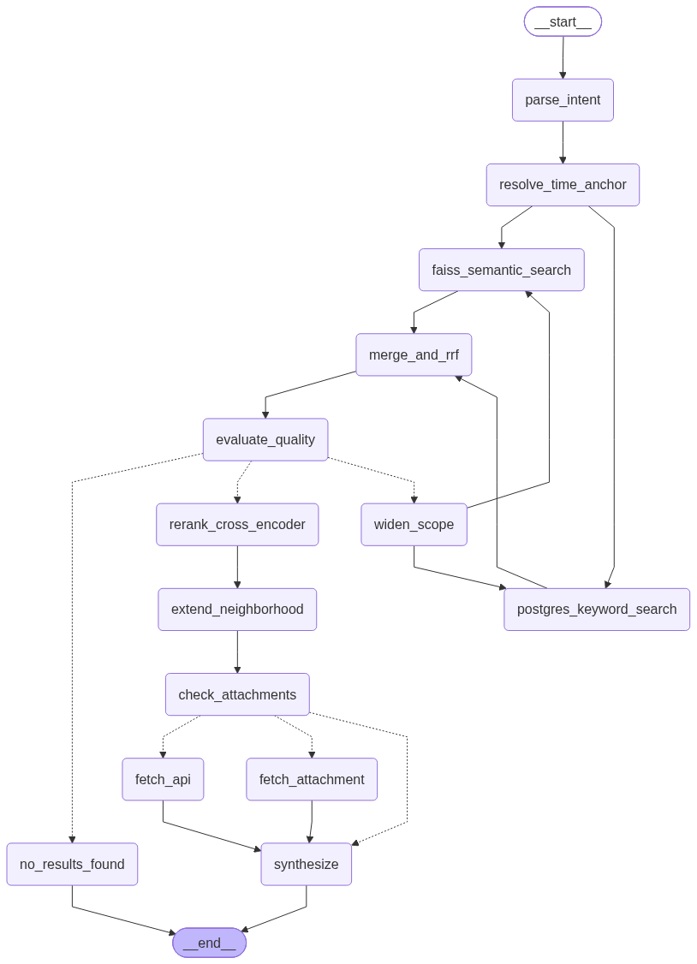
Figure 13: The live LangGraph, generated from the code (14 nodes)
Algorithm 2 — User-group suggestions (hybrid rules + KNN)
for each recent item, for each active group:
if group has < 6 confirmed items: skip # not enough examples yet
rule = rules matched / total rules
knn = mean cosine similarity of the 3 most similar confirmed members
score = 0.5 x rule + 0.5 x knn
if score > 0.70 or rule > 0:
add suggestion with decision = 'pending'
# weekly review: accept -> item joins the group
# reject -> item is never added
Human-in-the-loop by design: an item enters a user group only through an explicit user action — adding it by hand, or accepting a suggestion in the review queue.
  - Implementation and Results
Results obtained
- All three sources captured into one PostgreSQL store.
- Enrichment tracks pending / processed / failed; failed items are retried on demand.
- Multi-turn natural-language questions answered.
- Wellbeing analytics implemented — live-data validation pending.
How the initial approach was fine-tuned
Three changes were made since Phase II:
Aspect | Phase II plan | Phase III approach — and why
Ranking | One weighted sum: 40% semantic + 30% engagement + 20% recency + 10% effort | Merge keyword and semantic lists by rank (RRF, k = 60), then re-score: 0.8 × cross-encoder + 0.2 × effort. Why: the two searches score on different scales, so adding raw scores is unfair.
Recency | 20% boost for recent items | Dropped on purpose, so older but still-relevant memories are not pushed down.
User groups | Suggested items auto-accepted | Suggestions start as pending; an item joins a group only after the user accepts.

- Benefits: fairer merge of keyword and semantic results; candidates re-scored against the actual question; still exactly 2 LLM calls; the user stays in control of groups.
- Drawbacks: the cross-encoder adds CPU time to every query; one more local model to download and load.
Progress so far — 80% complete
Area | Status
Capture (Gmail, Chrome, YouTube), storage engine, enrichment, 14-node hybrid retrieval engine | Done — shown at Review 1
Regret marking | New since Review 1
User groups | New since Review 1
Wellbeing API routes for the dashboard | New since Review 1
UI (10%): finish the dashboard screens and the extension popup | Remaining
Cleanup (10%): fix breaking paths, add logging, clean code, remove dead code | Remaining

The wellbeing module is implemented; its validation on live data is pending and scheduled in October.
Suggestions from Review 1
Suggestion from the panel | Response
Data retention timeline: keep captured data for a fixed period (6 months or 1 year), then delete it automatically to save storage, as production systems do | Planned as future work — a configurable auto-delete window (6 or 12 months).
Spam filtering: add a model that filters out spam emails before they are captured | Mail that Gmail already flags as spam is never captured, since the connector reads mail without the Spam folder; a dedicated spam model is planned as future work.
Focused presentation: frame the demo to show only what is needed and leave out what isn't | We have kept this review to the point — it shows only what is needed, up to the Digital Wellbeing module.

  - Further Exploration Plans and Timelines
Target: 100% complete in the last week of October.
Week | Work | Share
October · Week 1 | UI completion: implement wellbeing screens and popup; connect to the API | UI — 10%
October · Week 2 | UI completion: citation cards, source-breakdown chart, group-review polish | UI — 10%
October · Week 3 | Refactor and hardening: fix breaking paths, add logging, remove dead code. Validation: end-to-end run of all 3 sources; WBA on live data | Cleanup — 10%
October · Week 4 (final) | Final testing, retrieval quality check, privacy check, documentation | Validation and finish

Carried forward from Review 1: wellbeing validation, dashboard refinements, end-to-end validation, retrieval quality measurement, privacy audit, and documentation — all covered above.
Beyond the capstone, two items remain as future work from the Review 1 suggestions: a configurable auto-delete window for stored data (6 or 12 months), and a dedicated spam-filtering model.

Appendix A: Definitions, Acronyms and Abbreviations
Term | Definition
E.C.H.O. | Efficient Contextualized History Orchestrator — this system
GMC / CHC / YTC | Gmail, Chrome, and YouTube connectors (capture modules)
STE | Storage Engine — the single write path to PostgreSQL, FAISS, and Redis
ENP | Enrichment Pipeline — background worker that cleans, embeds, and classifies items
RSE | Retrieval and Synthesis Engine — the LangGraph that answers questions
WBA | Digital Wellbeing and Analytics module
UIL | User Interface Layer — React dashboard, extension popup, and FastAPI gateway
LLM | Large Language Model; called exactly twice per question (parse, synthesize)
FAISS | Facebook AI Similarity Search — library for fast nearest-neighbour search over vectors
RRF | Reciprocal Rank Fusion — merges ranked lists by rank: score = Σ 1 / (60 + rank)
Cross-encoder | A model that reads the question and an item together and scores their relevance
KNN | K-Nearest Neighbours — here, the 3 most similar confirmed members of a user group
FTS | Full-text search in PostgreSQL
MV3 | Chrome Extension Manifest Version 3
OAuth | Open Authorization — lets E.C.H.O. read Gmail and YouTube data without storing passwords
TTL | Time-to-live of a Redis key: 24 hours for revisits, 1 hour for attachment text
EchoState | The TypedDict passed between the nodes of the retrieval graph
Memory item | One captured unit of activity: one email, one web page, or one video
Intent gate | Rules that keep only activity the user actually paid attention to
Dwell time | Foreground time on an email or page while the user is active
Effort score | 0-to-1 measure of attention: time, scroll, revisits, interactions, completion
System group | One of five fixed categories: work, study, entertainment, personal, misc
User group | A user-defined category (e.g. "Placement preparation") managed with approval
Session | Consecutive activity with gaps of at most 5 minutes
Regret event | A user's own mark on an item; each mark or unmark is a new row

Appendix B: References
REFERENCES (IEEE Format):
[1] N. Reimers and I. Gurevych, "Sentence-BERT: Sentence embeddings using Siamese BERT-networks," in Proceedings of the 2019 Conference on Empirical Methods in Natural Language Processing, 2019.
[2] J. Johnson, M. Douze, and H. Jégou, "Billion-scale similarity search with GPUs," IEEE Transactions on Big Data, vol. 7, no. 3, pp. 535–547, 2021.
[3] LangChain and LangGraph Documentation, "Building language model applications with composable components," https://python.langchain.com, 2024.
[4] M. Kleppmann, A. Wiggins, P. van Hardenberg, and M. McGranaghan, "Local-first software: You own your data, in spite of the cloud," in Proceedings of the 2019 ACM SIGPLAN International Symposium on New Ideas, New Paradigms, and Reflections on Programming and Software, 2019.

Appendix C: Record of Change History
# | Date | Document Version No. | Change Description | Reason for Change
 | Mar 2026 | 0.1 | Scope and high-level architecture defined: three sources, intent-first capture, local-first storage, 16-table schema | Phase II baseline design
 | Apr 2026 | 0.2 | Capture connectors and a single Storage Engine write path with de-duplication | Phase II implementation
 | May 2026 | 0.3 | Enrichment pipeline and first retrieval graph with a self-correcting loop | Phase II evaluation
 | Jul 2026 | 0.4 | Retrieval redesigned: hybrid search, RRF fusion, cross-encoder re-ranking; recency weighting removed; LLM provider made swappable | Fairer ranking and reliable LLM access
 | Aug 2026 | 0.5 | System integrated end to end: capture → storage → enrichment → retrieval | Phase 3 Review 1
 | Sep 2026 | 1.0 | Wellbeing module added with human-in-the-loop user groups; this document | Phase 3 Review 2

Appendix D: Traceability Matrix
Forward and backward traceability from the requirements (Project Scope Document, v2.0) through the high-level design (Architecture Design Document) to this low-level design.
Project Requirement Specification Reference Section No. and Name. | DESIGN / HLD Reference Section No. and Name. | LLD Reference Section No. Name
§4 Module 1 — Gmail Module | §5 Gmail Module (GMC) | 3.2 Module 1 — GmailConnector
§4 Module 2 — Chrome Browsing Module | §6 Chrome Browsing Module (CHC) | 3.2 Module 1 — ChromeConnector
§4 Module 3 — YouTube Module | §7 YouTube Module (YTC) | 3.2 Module 1 — YouTubeConnector
§4 Module 5 — Canonical Memory Module (Storage Engine) | §4 Storage Layer; §15 Database Schema | 3.2 Module 1 — StorageEngine, FAISSManager
§4 Module 6 — Enrichment Pipeline | §8 Enrichment Pipeline; §9 System Group Classification | 3.2 Module 1 — EnrichmentPipeline, SystemGroupClassifier
§4 Module 4 — Unified Retrieval Module (LangGraph RSE) | §10 LangGraph Retrieval & Synthesis Engine | 3.3 Module 2; 4.1 Algorithm 1
§4 Module 7 — Digital Wellbeing and Analytics Module | §11 Digital Wellbeing Module (WBA) | 3.4 Module 3; 4.1 Algorithm 2
§4 Module 8 — User Interface Layer | §12 User Interface Layer (UIL) | 3.5 Packaging and Deployment; 4.3 Timelines
§2 Core Design Principles (privacy, non-judgmental wellbeing) | §13 Privacy & Ethics | 2 Design Constraints

